Push+Protect Solution

Training Guide

Training Guide
2020
IoT in a Box® 4
Push+Protect Monitoring Solution 4
What’s included? 5
Customizable Web and Mobile Apps 5
Gateways 5
Buttons 5
Beacons 5
Getting Started 5
Locations/Departments 6
Guided Setup 7
Preconfigured Devices 7
Gateways 8
Gateway Deployment 8
Installation Steps 9
Beacons 10
Beacon Deployment 10
Installation Steps 11
Buttons 12
Installation Steps 12
Device History 13
Alerts 13
Alert Types & Settings 13
Stop an Emergency Alert 14
User Management 15
How to Add Users 16
Reports 17
Incident Report 17
Incident Report Settings 18
Sensor Maps 19
Map: Animation Marker & Sound 20
Pin to Home screen 20
Customized Maps 21

IoT in a Box®

myDevices introduces IoT in a Box®, turnkey solutions that address remote monitoring challenges for a variety of verticals. Plug-and-play gateway and sensors are pre-configured with a LoRaWAN™ network connection and can be up and running in minutes.

Push+Protect Monitoring Solution

Eliminate the time and effort of piecing together IoT solutions using our out-of-the-box ready Push+Protect Monitoring solutions. Our solution solves the unique and complex monitoring challenges by combining plug-and-play hardware with industry-leading monitoring applications, real-time reporting, and instant SMS text message alerts tailored for your vertical.

- Hospitality
- Healthcare
- Food Service
- Retail
- Education
- Facility Management

What’s included?

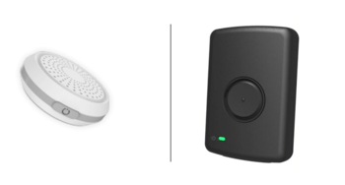

Beacons & Buttons
Gateways
Customizable Web & Mobile Apps

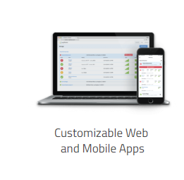

myDevices IoT in a Box® provides you with tools to remotely monitor your business locations.

Customizable Web and Mobile Apps
- Monitor and control your companies, departments and locations by grouping gateways & sensors on a single dashboard using full-featured apps.
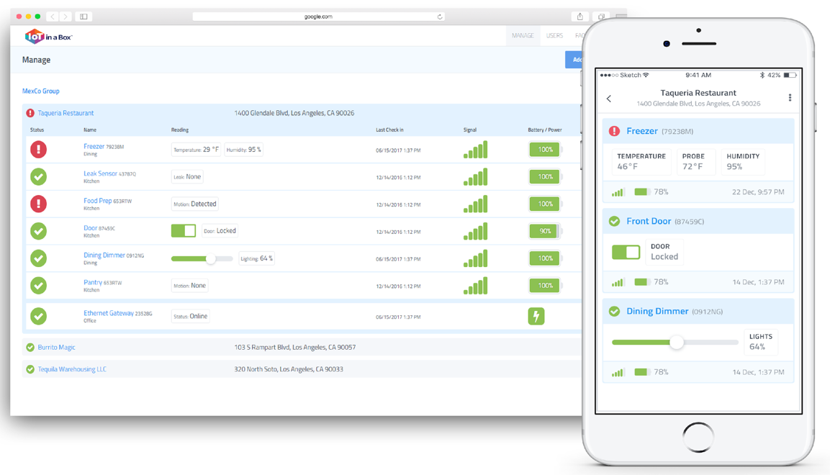

Gateways
- Preconfigured to work right out of the box – just add the gateway to your account by scanning the QR code on the back of the gateway.

Buttons
- Automatically connect with your gateway device – just scan the QR code on the back of the device and the sensor will automatically start sending data to the gateway periodically.

Beacons
- Automatically connect with your button device – just scan the QR code on the front of the device and the sensor will automatically start sending data to the button periodically.

Getting Started
This training guide will provide you a complete overview on how to manage your Push+Protect monitoring solution with the myDevices IoT in a Box® Solution.

Installed accounts would normally have an Account Administrator identified and created in the solution. New customers should setup their Account Administrator profile before adding devices.

- Create your account and add the main address of your facility.

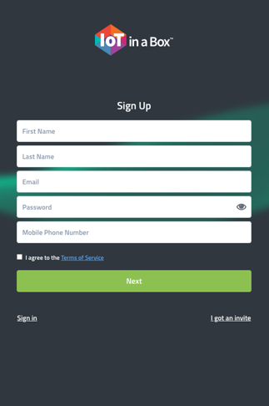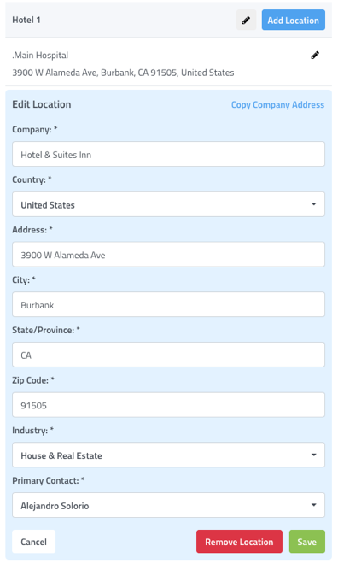

Locations/Departments

Remotely manage all of your sensors regardless of location from a single dashboard. Using our Web or Mobile apps you can contemporaneously get an overview of the status of any location or device. Stay at a high level to get an overview of the location or drill down to view current and historical device readings.

- Select Add Location to add and name additional areas to your account

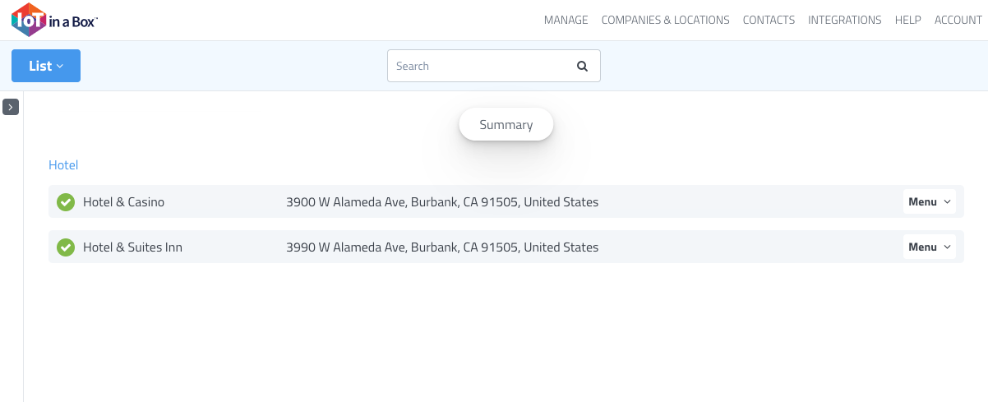
TIP: Users may be assigned to one or all locations

Guided Setup

Get up and running quickly. After signing into your new account, use our guided setup to walk through setting up your Locations, Gateways and adding your devices.

TIP: If you plan to adjust sensor placement, please ensure the following tools are handy.

Preconfigured Devices

Our setup process makes adding new Gateway or Sensor devices pain free. Devices delivered to you preconfigured to work with your solution. To add your device, simply scan the QR code located on the back of the device.

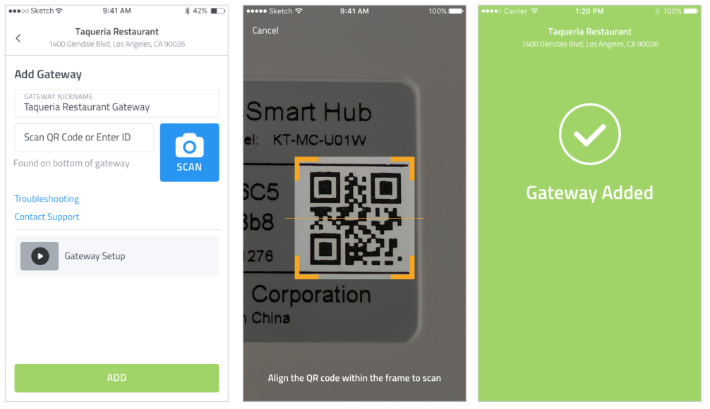

Gateways
Our devices are interchangeable, and each will work with any of your sensors.
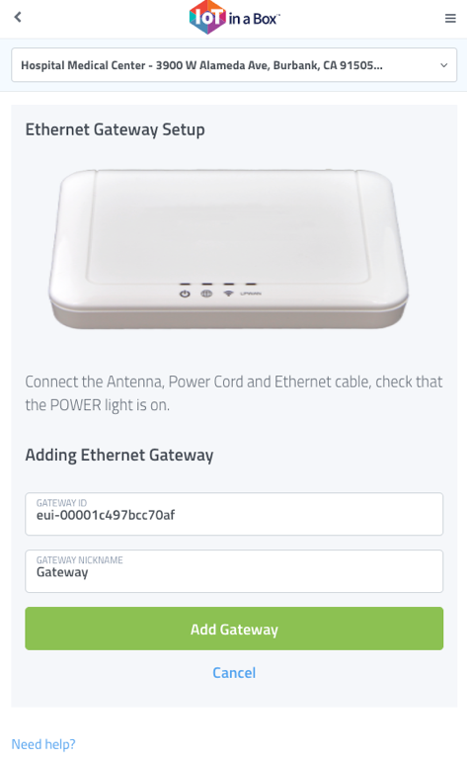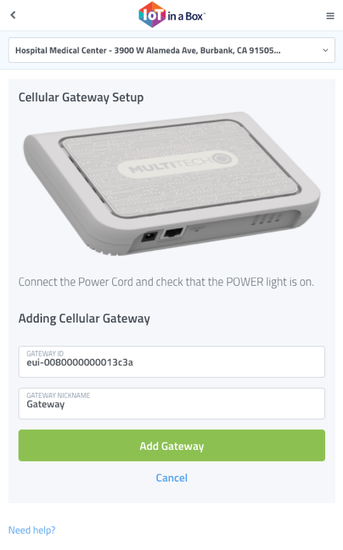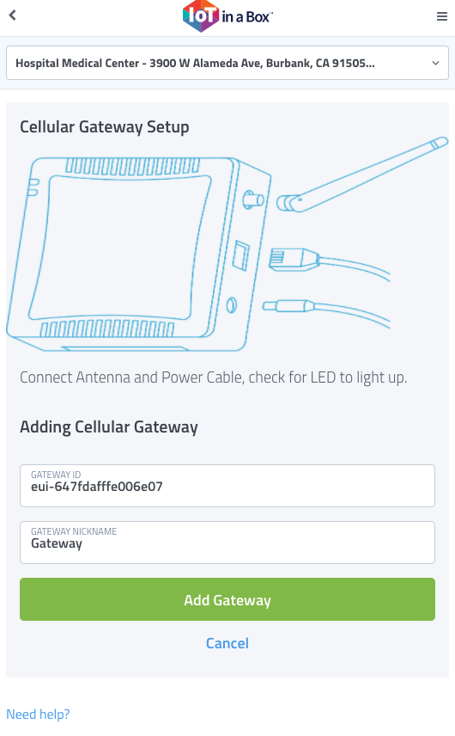

Gateway Deployment
Gateways enable communication between the application and your buttons. To ensure optimal coverage ensure your Gateway is installed.

- How many gateways are required per property deployment?
  - Most commonly, 1 gateway per floor (depends on property size)
- Where do the gateways need to be placed on the property?
  - The gateways are commonly installed on alternating sides of the building for each floor about 1/3 of the way inside from the edge of each floor.
  - While not required, gateways are commonly installed in IDF/Electrical Closets.
- What is the maximum distance from the gateway to the panic button to still be effective?
  - Range depends on building density due to walls, doors, and windows. The typical maximum range is 1,000 feet radius coverage from device to gateway. Gateways installed on all floors as recommended are sufficient and provide the necessary redundancy.

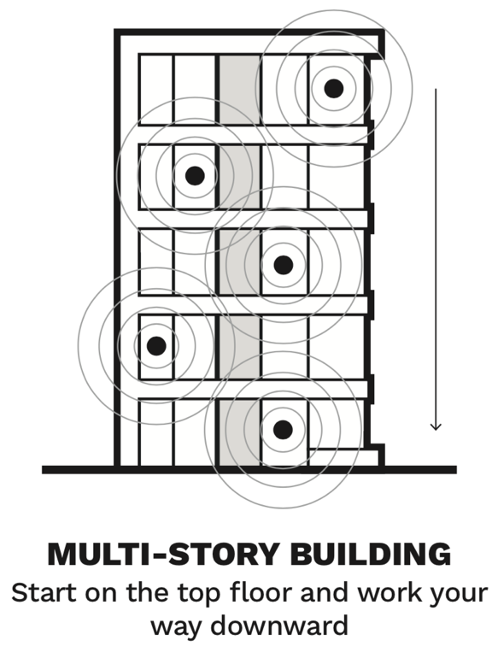
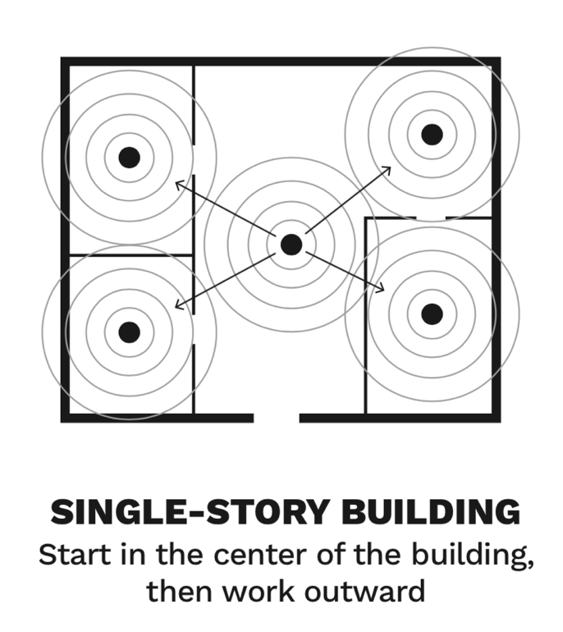

Installation Steps
- Scan in Gateway
- Power on Gateway and wait 3 min for each device to power on
- Secure Gateway with double-sided tape in ideal location

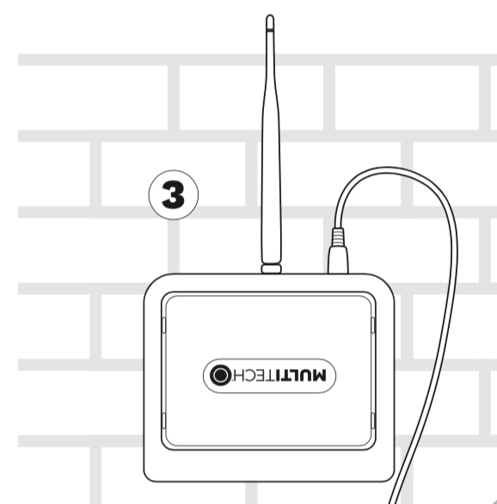

Beacons
Our Bluetooth enabled beacons communicate and transmit their locations to your panic buttons, which in turn communicate to your gateways with real-time locations.

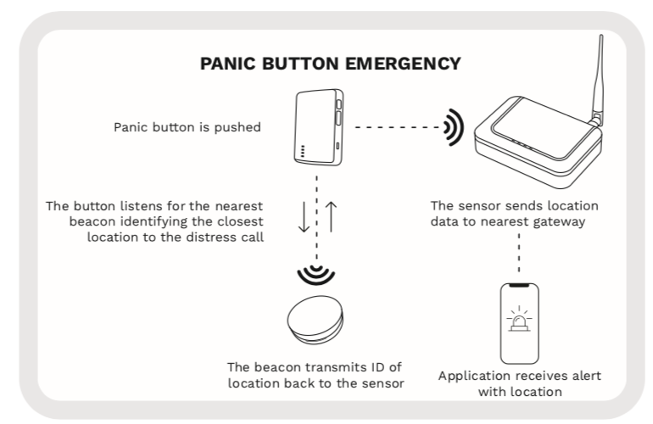

Beacon Deployment
Beacon placement can easily be adjusted dependent on size of the area to cover.

- Does it provide pinpoint location accuracy?
  - Yes. Bluetooth beacons are placed in rooms and other desired areas to determine the location of where the panic button is pressed
- Are beacons wired?
  - No. Beacons are wire-free battery operated
- How long do beacon batteries last?
  - Approximately 3 years
- Does the system require to be configured to the property's network?
  - No, the system does not use ethernet or wi-fi and is 100% off-network.

Installation Steps
- Scan beacon into app and power on the device
- Install beacon(s) in the back and center of rooms, facing entryway
- Test placement in all areas (entryway and bathroom)

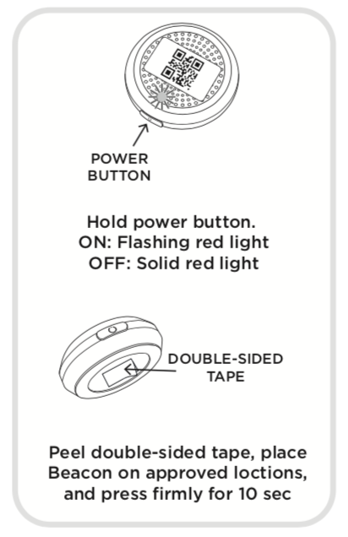

Buttons
Our rechargeable panic buttons provide real-time updates during an emergency and GPS updates when no beacons are present. Buttons will only communicate when in distance to the gateways.

- Are the panic buttons portable?
  - Yes. These devices are wireless/battery operated.
- How long do push button batteries last?
  - 6 months. The panic button batteries are rechargeable.
- Do the employees require a smartphone to use the panic button?
  - No, the panic buttons do not require to be paired to the employee's smartphone.
- Does it provide pinpoint location accuracy?
  - Yes. Bluetooth beacons are placed in rooms and other desired areas to determine the location of where the panic button is pressed.

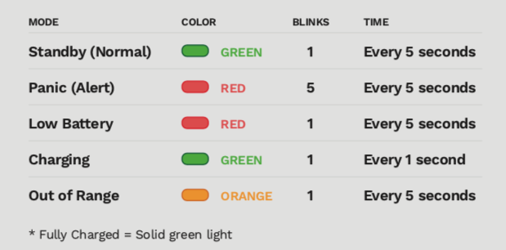
TIP: The panic button’s LED light flashes either GREEN, RED, or ORANGE

Installation Steps
- Scan sensor into the app and turn on the alert
- Fully charge the button with mirco-usb before use
- Press twice to activate an emergency alert. Stop alert via the app

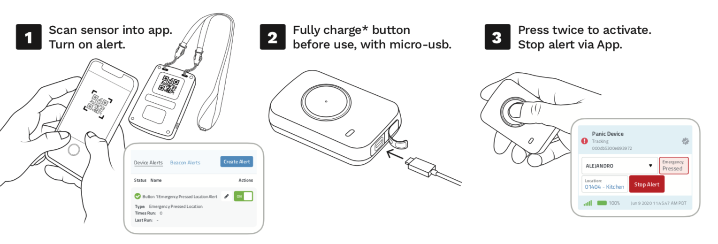

Device History

Our platform maintains a history of Device readings, Alert notifications, and Reports delivered. Using the Web or Mobile apps you can dig into the historical data, filter to show exactly what you need and download for your records or for offline viewing.

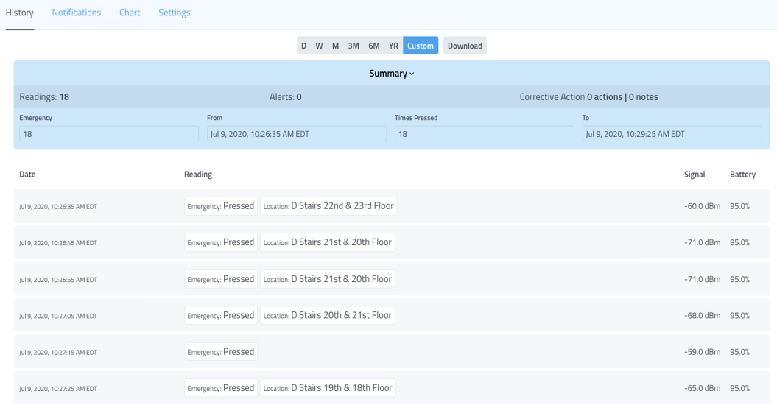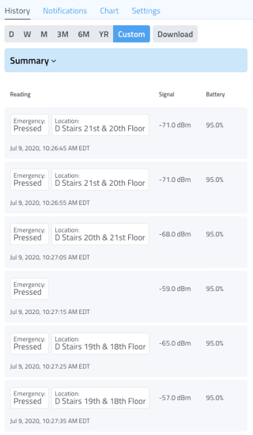

Alerts

Receive notifications when devices trigger rule conditions. Our Alert system allows for customization of alerts – you control the conditions for alerting and who gets notified. Recipients can be notified via Text or Email message.

Alert Types & Settings

There are 4 alert types that can be managed in the solution.
- Gateway Online/Offline Alert – notifies users when a Gateway is offline and online
- Emergency Alert – notifies users when a panic button is pressed in an emergency
- Beacon Battery Alert – notifies users when the beacon’s battery is below a threshold limit
- Button Battery Alert – notifies users when the button’s battery is below a threshold limit

The following settings will be required to configure for each alert type.

- Gateways
  - Alert Recipients – Email only
- Emergency
  - Alert Recipients – Select Email and/or Text
- Battery Alerts (Button & Beacon)
  - Thresholds – min and maximum battery % range
  - Alert Recipients – Select Email and/or Text

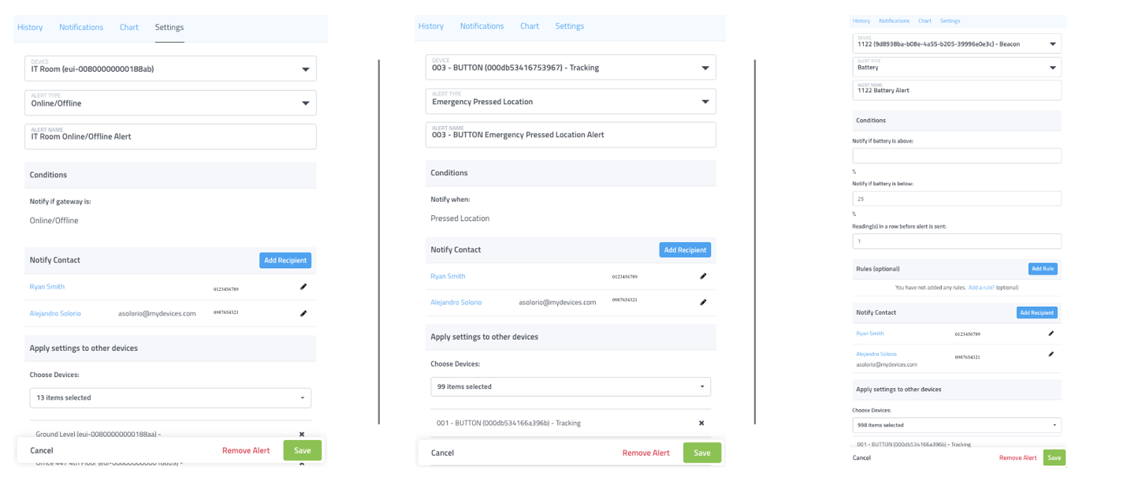
TIP: Edit 1 alert & use Apply Settings to Other Devices to copy settings to all devices with similar settings

Stop an Emergency Alert

Use a combination of GPS trackers and location-based beacons to help satisfy State and Local Governmental requirements for employers to protect against workplace harassment and violence. Easy-to-use push-buttons and room-level accuracy provide the ability to locate staff in an emergency.

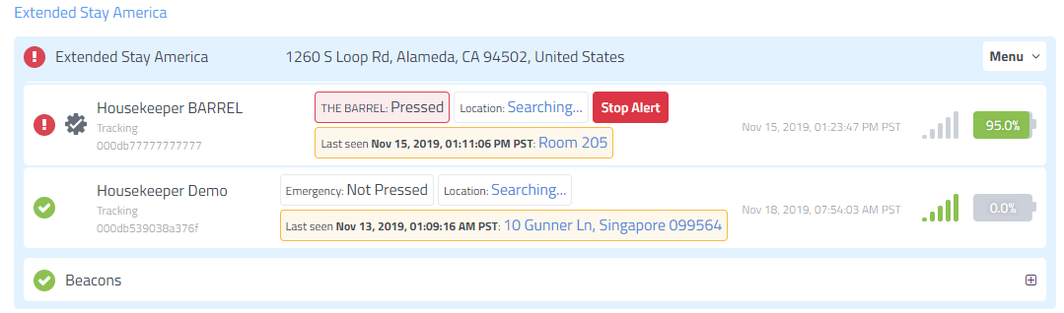

When an alert is triggered, and after an emergency has been resolved, any user may login to the app and press Stop Alert to reset the device and prevent future notifications from being sent to all users.

During an ongoing alert, tracking information is updated to reflect the location of the tracker using location-based beacons to provide room-level accuracy or GPS information to provide location elsewhere on the property. As the tracker changes position, the last known location can be shown on the location floor plan. All users receive a final notification when the alert is stopped.

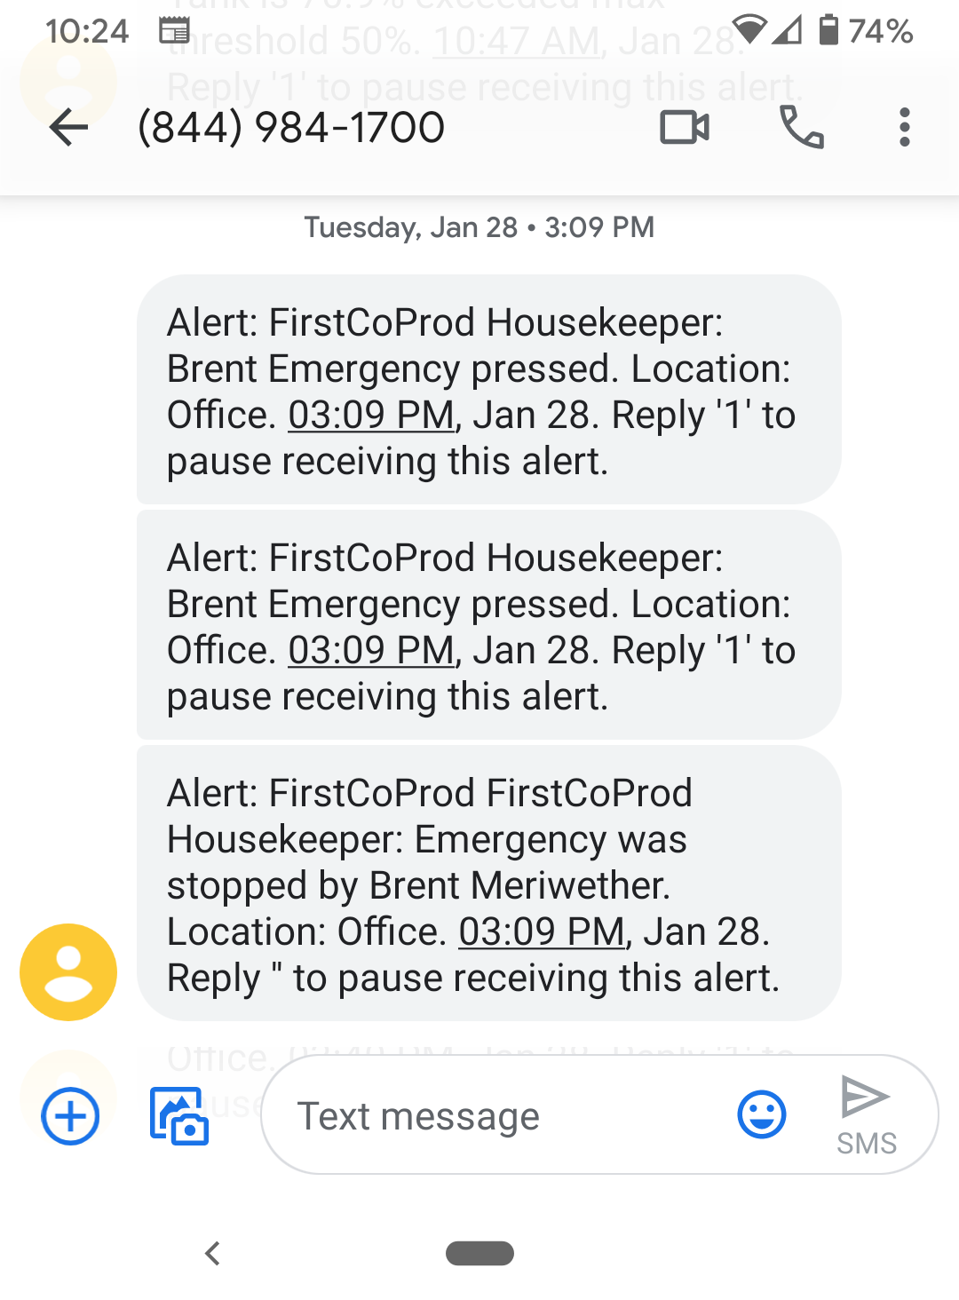

User Management

Easily review and control the various users, team members, personnel and contacts for at your various companies and locations. Quickly update contact information or Invite additional users to help manage locations through the Web or Mobile Apps. Define and control permissions to limit or grant access to account features, locations and facility access.

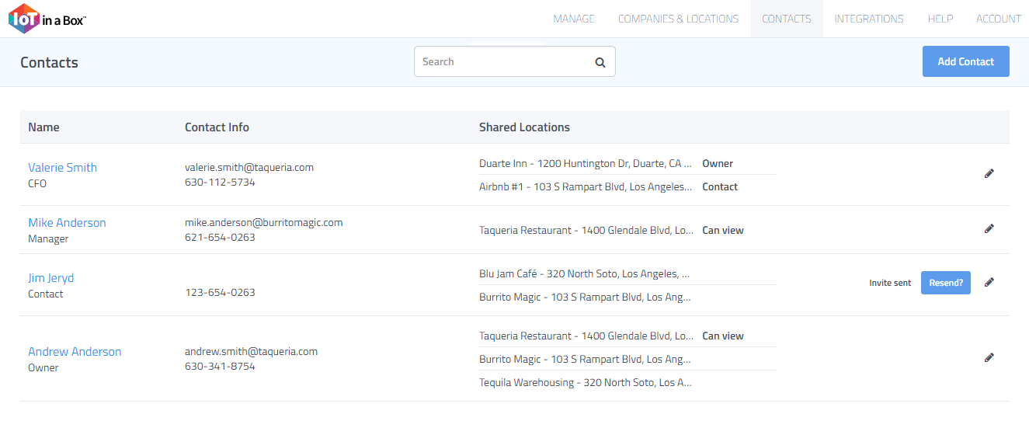

How to Add Users

Select Contacts > Add Contact (Blue) > Complete Profile > Add Contact (Green)

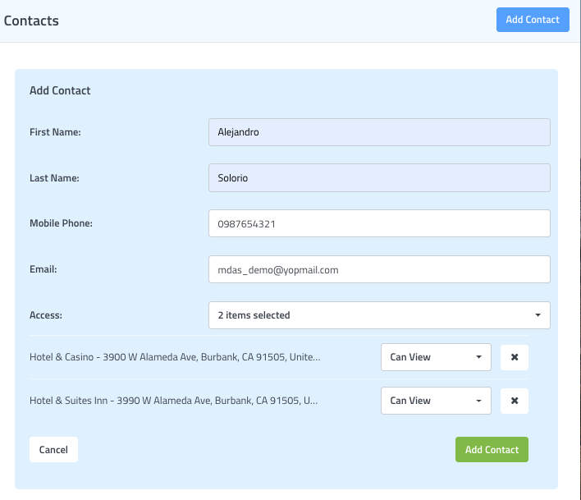

Reports

Our report types allow you to customize the data included by specifying any number of devices and readings, setting the time(s) for each reading, and choosing the number of days to include in the report. You select how much detail gets included in each of your reports.

The solution comes with the following report that can be implemented into your everyday workflow.

- Incident Report – provides a summary of any emergency alerts during a specified time

Incident Report

Receive a summary of push-button tracking device security and safety incidents. These reports contain a summary for each incident including details such as personnel involved, contacts notified as the incident transpired, as well as the times and locations where the incident started and stopped.

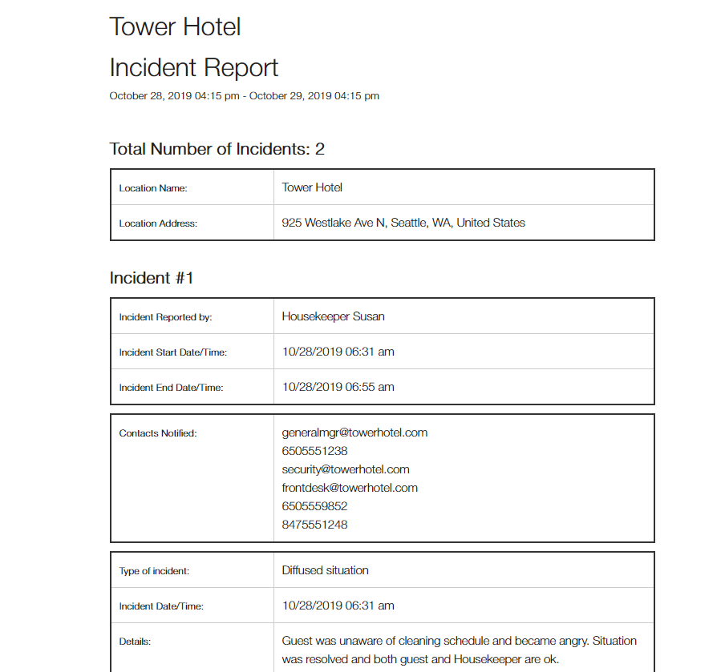

Incident Report Settings

- Report Name
- Frequency
  - Day of Week & Time
  - Weekly & Day of Week & Time
  - Monthly & Day of Month & Time
- Custom Message (Optional)
- Devices (Select: All)
- Alert Recipients (Email Only)

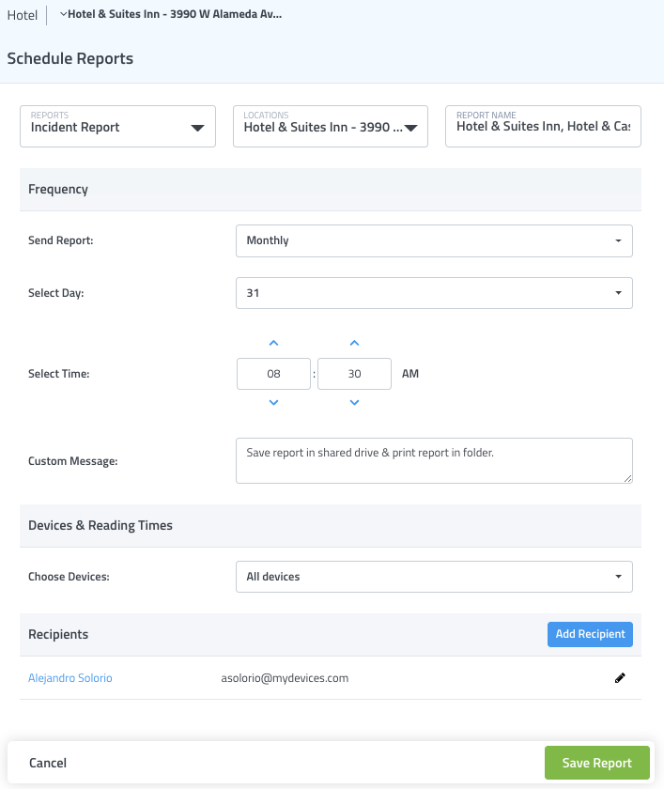

Sensor Maps

Easily view the status and position of your gateways & sensors on a Google Map or Image (such as a floorplan or photo of the location). Drag & drop icon markers to their correct position at the location and tap on them to pull up details on current status.

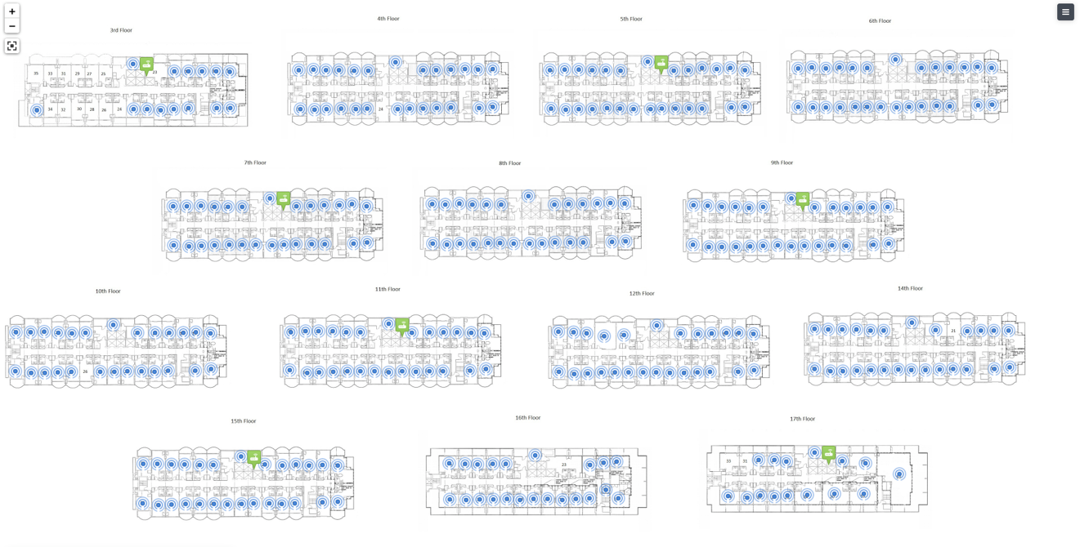

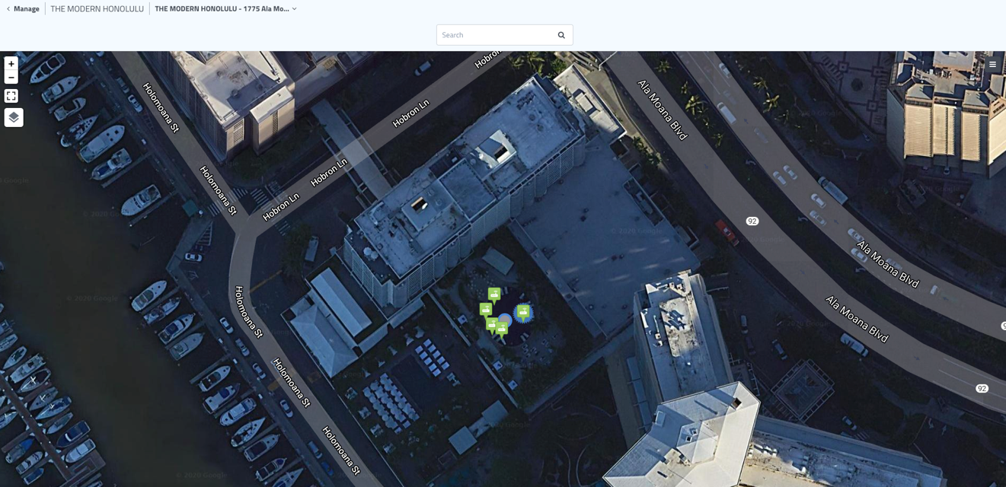

Map: Animation Marker & Sound

Map pinning allows users to customize their home screen view by selecting any of their location’s map or floor plans to become the default view. Users can also pin their most important sensor map screens to the list, allowing quick selection directly from the home screen.

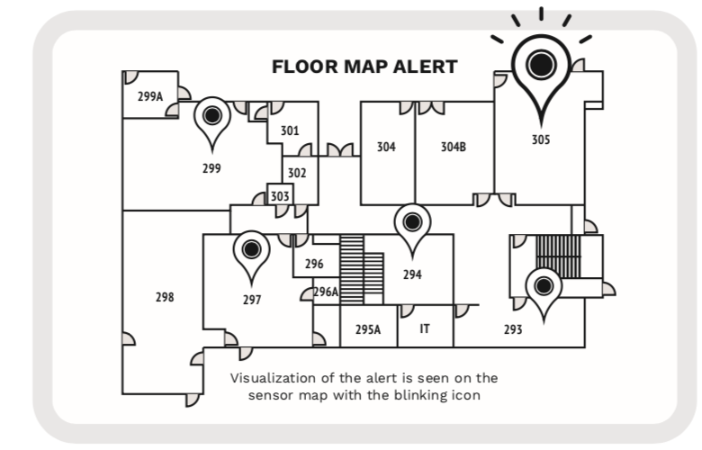

Pin to Home screen

Map pinning allows users to customize their home screen view by selecting any of their location’s map or floor plans to become the default view. Users can also pin their most important sensor map screens to the list, allowing quick selection directly from the home screen.

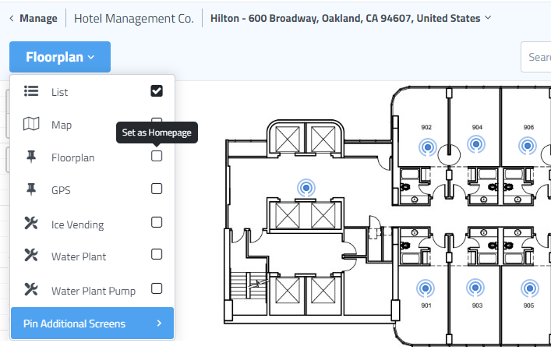

Customized Maps

Customize sensor map to adjust icon appearance, play a sound to call attention to alert conditions on the map.

Select Device Icon > Settings Icon

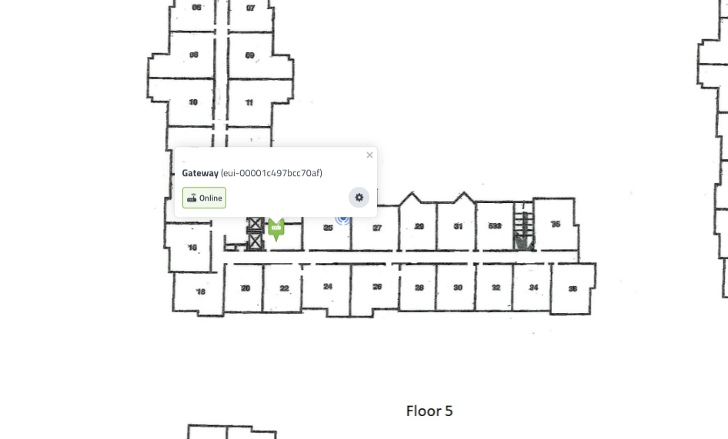

- Pin & Icon / Animation & Sound – turn on icon flashing & alert sound
- Custom Image – upload an image to represent your device icon

