Temperature Monitoring Solution

Installation Guide

Installation Guide
2020
IoT in a Box® 4
Temperature Monitoring Solution 4
Pre-Installation 5
Account Setup 5
Locations/Departments 5
Tools 6
Devices 7
Installation 7
Gateways 7
Sensors 11
Troubleshooting 18
Sensor Maps 19

IoT in a Box®

myDevices introduces IoT in a Box®, turnkey solutions that address remote monitoring challenges for a variety of verticals. Plug-and-play gateway and sensors are pre-configured with a LoRaWAN™ network connection and can be up and running in minutes.

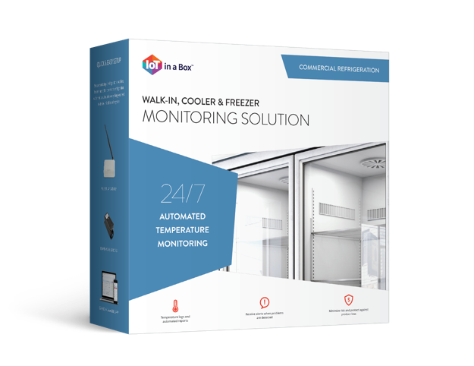
Temperature Monitoring Solution

Eliminate the time and effort of piecing together IoT solutions using our out-of-the-box ready Temperature Monitoring solutions. Our solution solves the unique and complex monitoring challenges by combining plug-and-play hardware with industry-leading monitoring applications, real-time reporting, and instant SMS text message alerts tailored for your vertical.

- Healthcare
- Food Service
- Retail
- Education
- Facility Management

Pre-Installation
This Installation guide will provide you a complete overview on how to manage your temperature monitoring solution with the myDevices IoT in a Box® Solution.

Account Setup
New customers should setup their Account Administrator profile before adding devices.

- Open your browser and navigate to www.iotinabox.mydevices.com
  - iOS Browser: Safari
  - Android Browser: Chrome

- Create your account and add the main address of your facility. Next, add additional departments/locations.

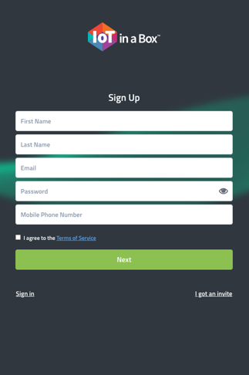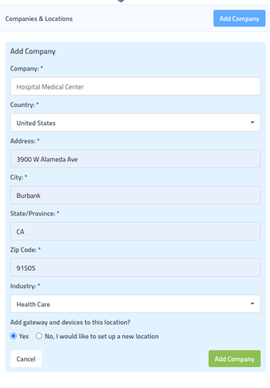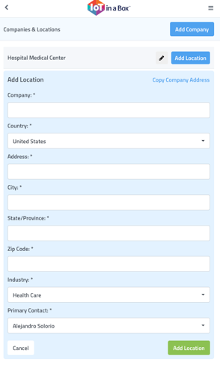

Locations/Departments

Remotely manage all of your sensors regardless of location from a single dashboard. Using our Web or Mobile apps you can contemporaneously get an overview of the status of any location or device. Stay at a high level to get an overview of the location or drill down to view current and historical device readings.

- Select Add Location to add and name additional areas to your account
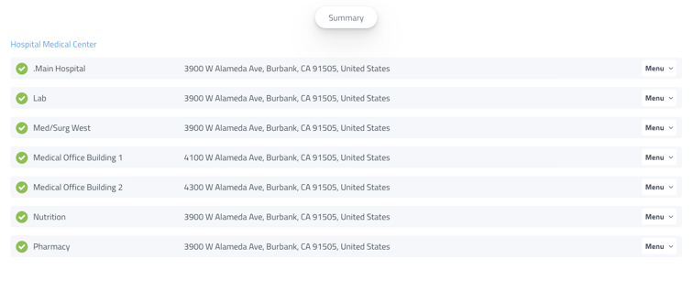

Tools

The following tools are required for installation:

- Zip-ties & anchors – for cable management
- Double-sided tape – for all devices
- Power drill – gateways can be secured to wall with screws (optional)

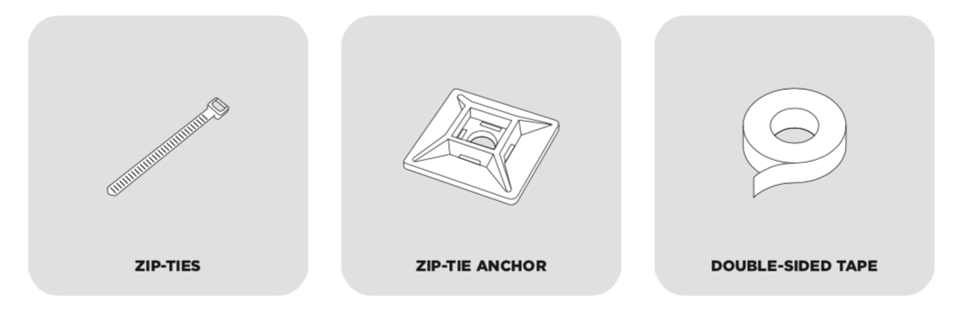

- Mobile Device – for system access to make quick updates as you install

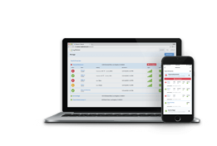

Devices

The following devices are required for temperature monitoring solution:

- Gateways - power on the entire system, any LoRa enabled device can be used

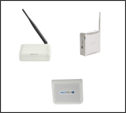

- Temperature Sensors – any LoRa enabled device can help manage all environmental monitoring solutions, our devices are interchangeable, and each will work with any of your gateways.
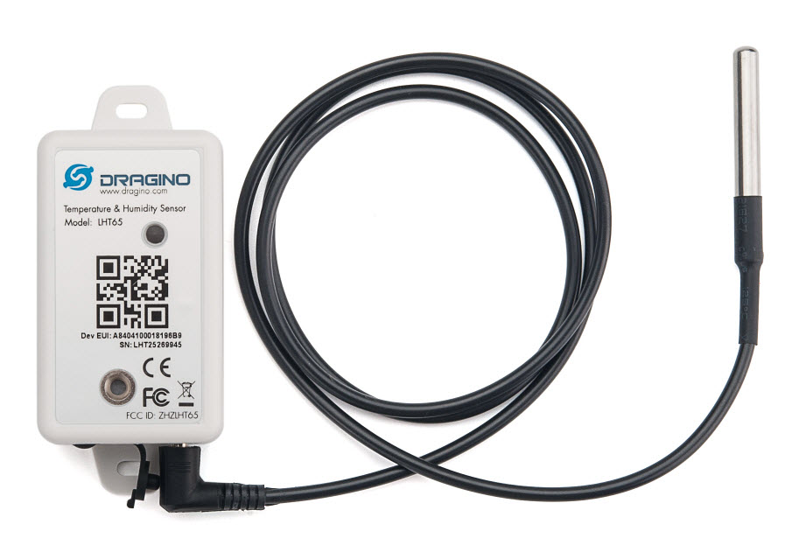

Installation

Gateways

Our setup process makes adding Gateways pain free, simply scan the QR code located on the back of the device to the correct location.

- Select the correct location to add the gateways. Menu > Add Gateway

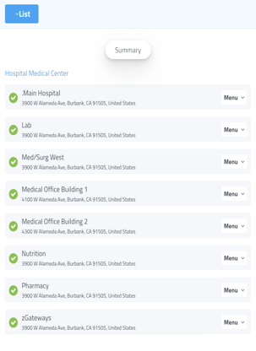

- Scan QR Code to add gateways

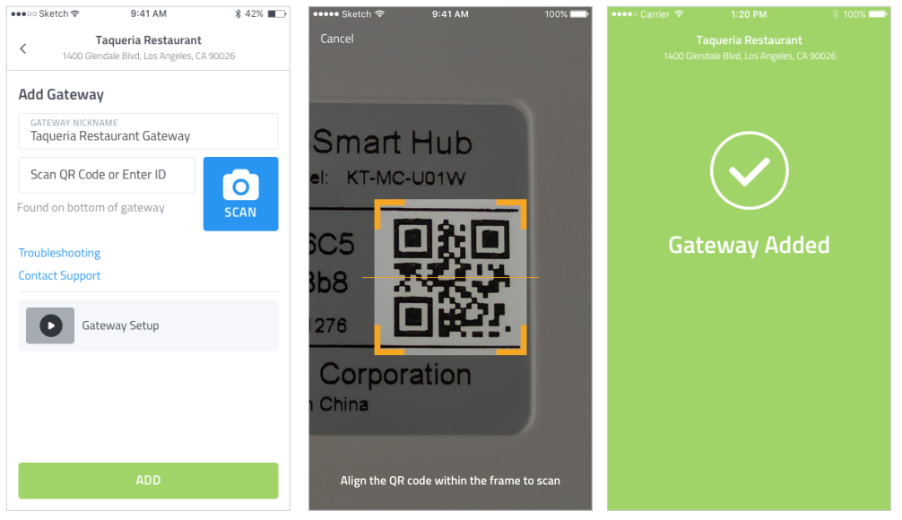

- Name Gateways based on area installed (e.g.: Behind Printer Managers Office, Behind Refrigerator on Wall, etc.)
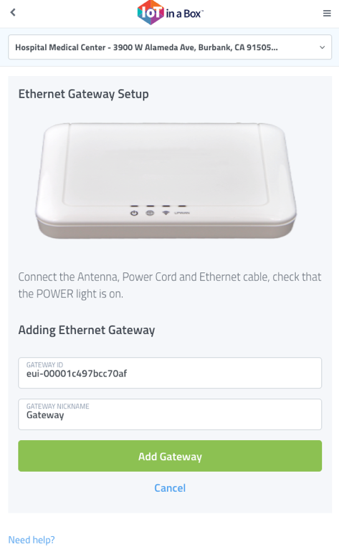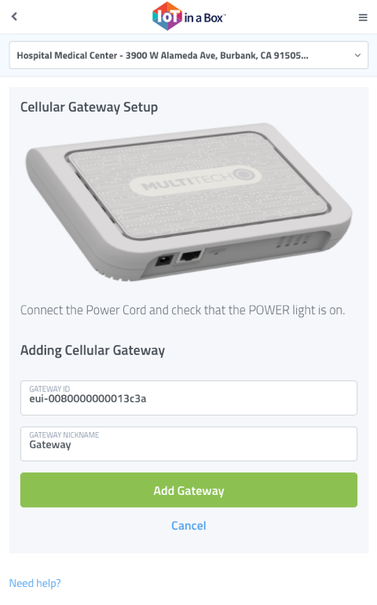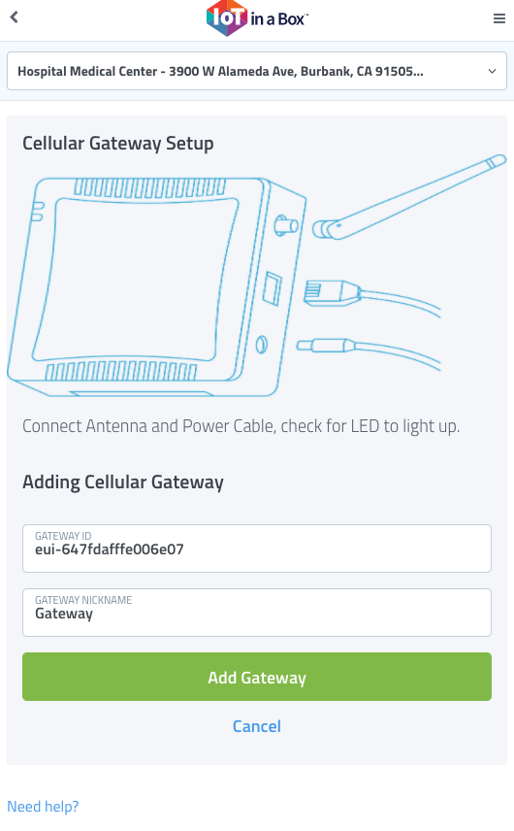

- Prepare Gateway with double-sided tape and power on. Wait approximately 3-5 min for the device to fully power on. The Gateways will show Online in the app when ready.
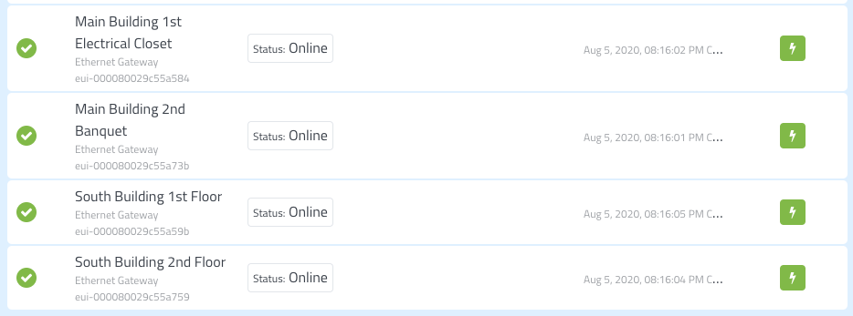

- Secure Gateway with double-sided tape or with screws.

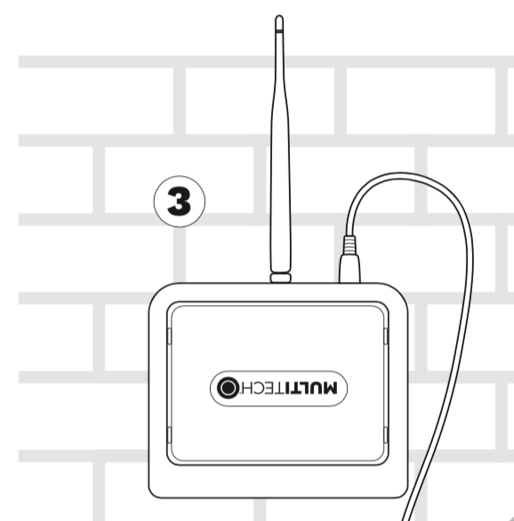

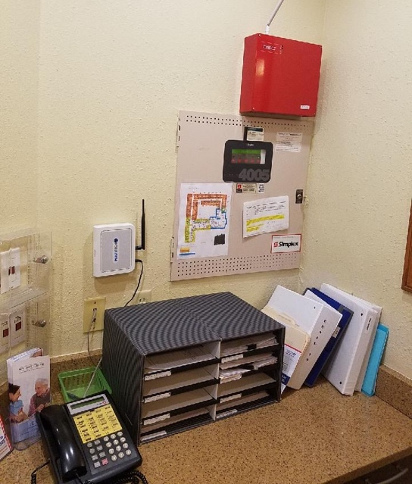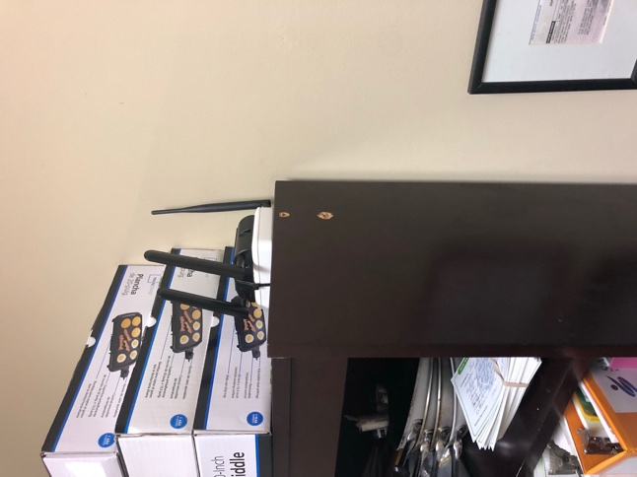

Sensors

Our setup process makes adding Sensors pain free, simply scan the QR code located on the back of the device to the correct location.

- Select the correct location to add the sensor. Menu > Add Sensor

- Scan sensor into app and enter Name, Device Use (Refrigerator, Freezer, Room, etc.), and Configuration (C or F).
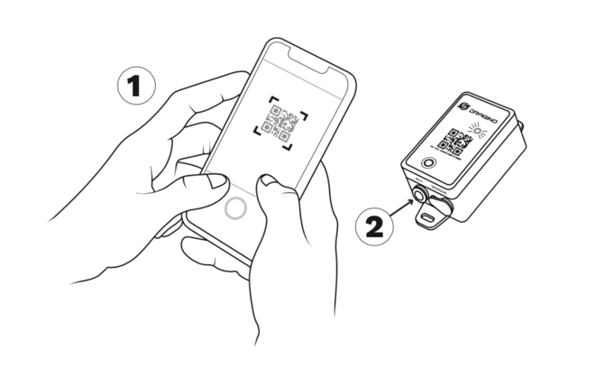

- Activate the sensor next to the gateway before installing

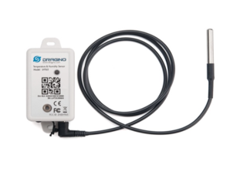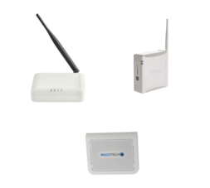

  - Hold ACT button for 5 seconds
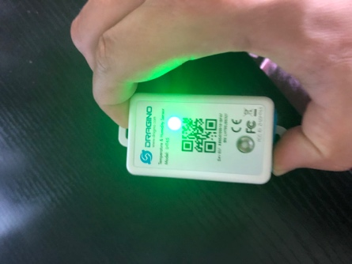
  - Release the ACT button upon green flashing light
  - Sensor will blink red until it connects online*

      - If you do not see a green light, stop here and contact support@iotinabox.com

      - If you do see a green light, sensor is online, continue to the next step
            - Sensor will not blink again, restart if you miss

- Your sensor is ready for installation. Secure the sensor with zip-ties, using racks or shelves inside the unit.

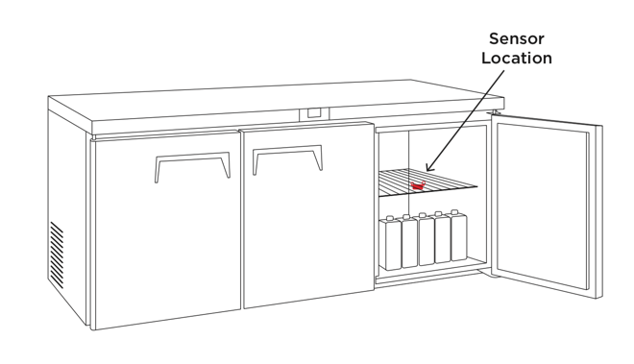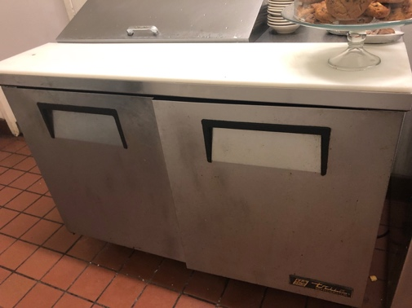

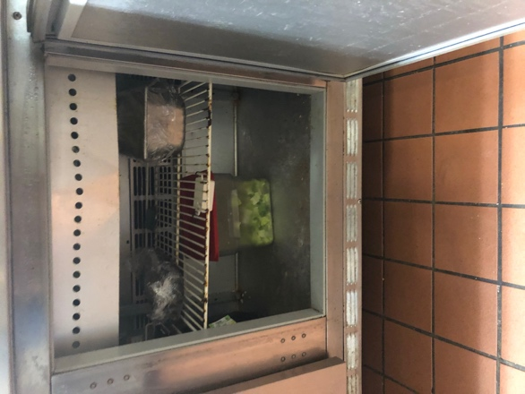

Grill Prep Coolers

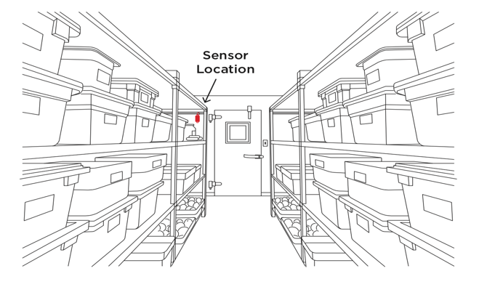

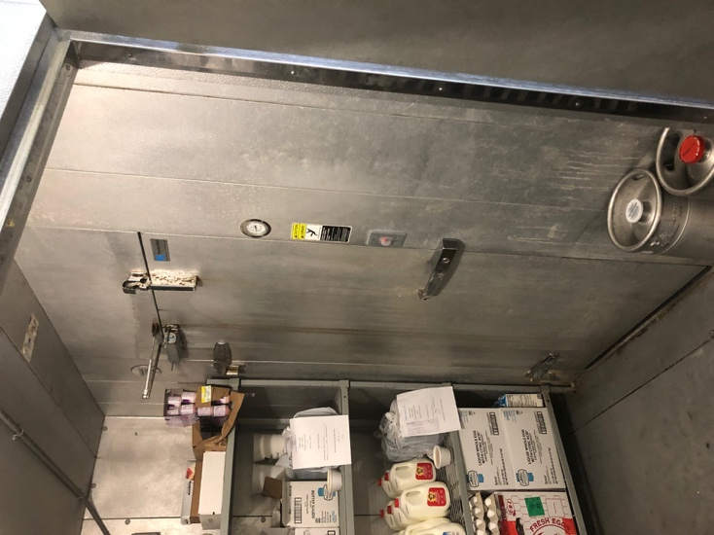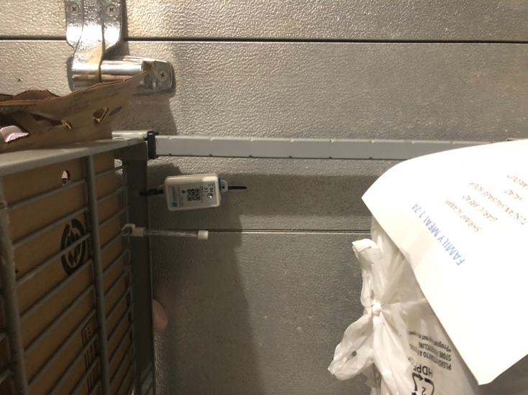

Walk-in Coolers & Freezers

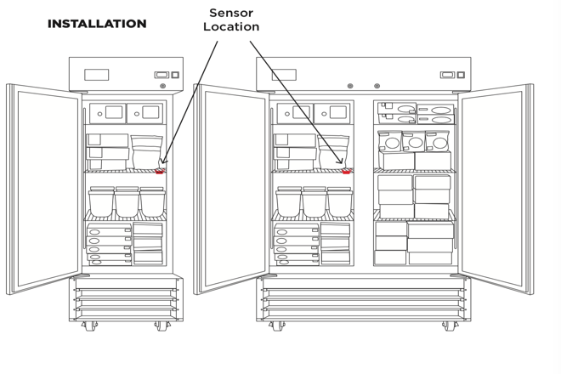

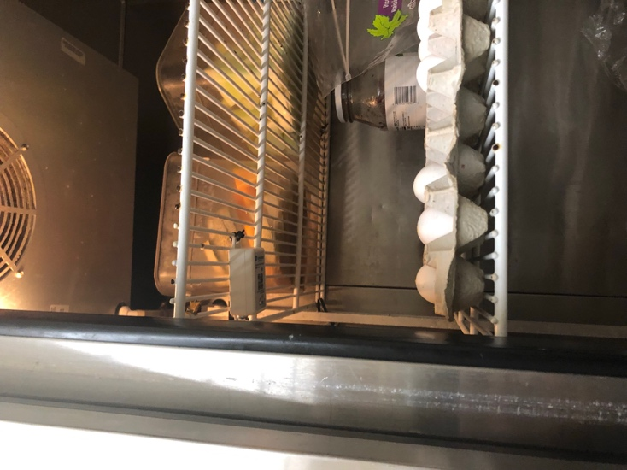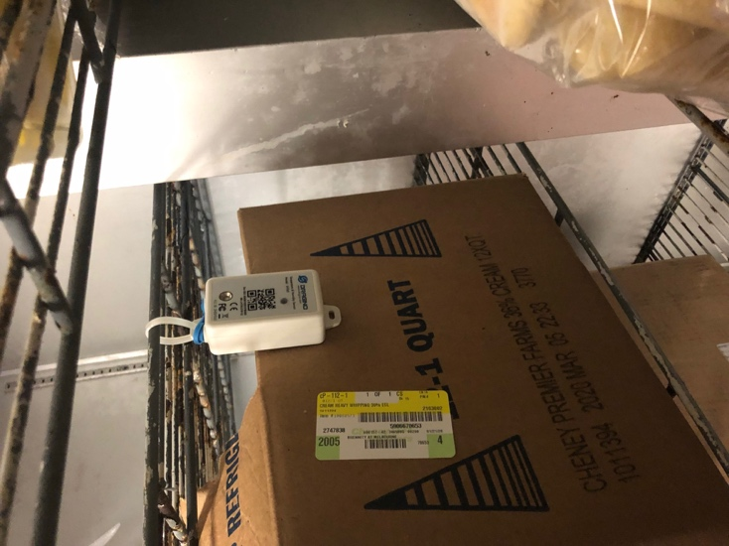
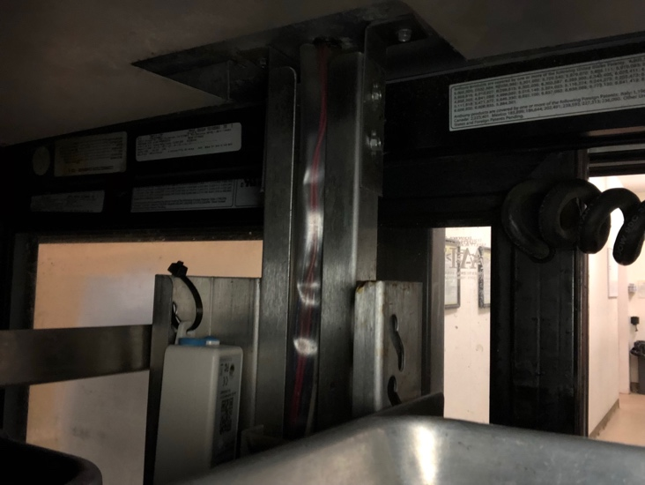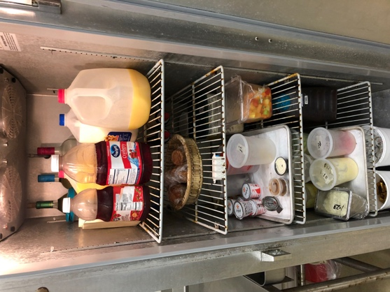

Single / Double Door Refrigerator

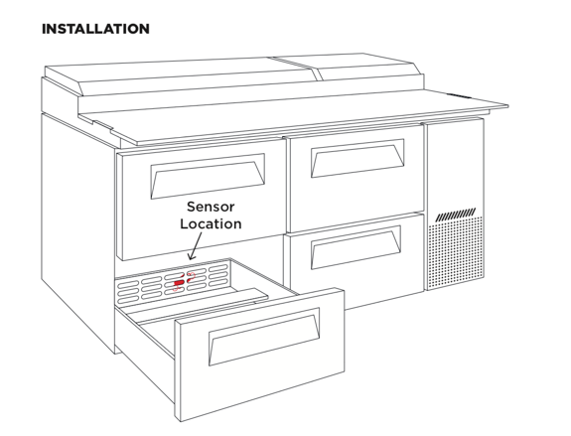

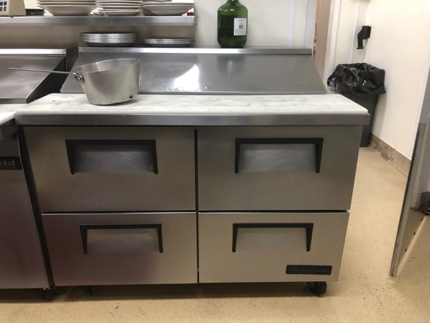

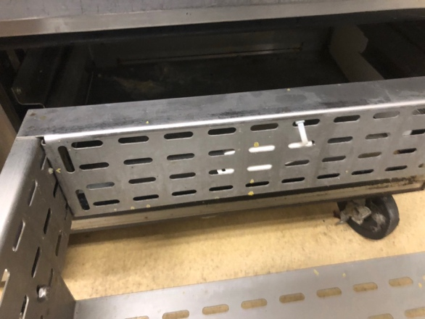

Undercounter Prep Grill

- Additionally, devices may be mounted to the inside of your refrigerator with double-sided tape. Vials with Glycol or Glass Beads come with a mounting bracket for the vial.

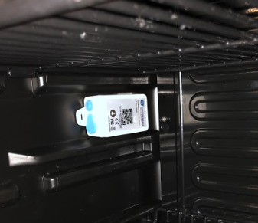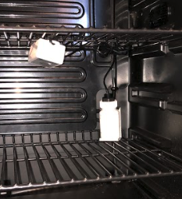

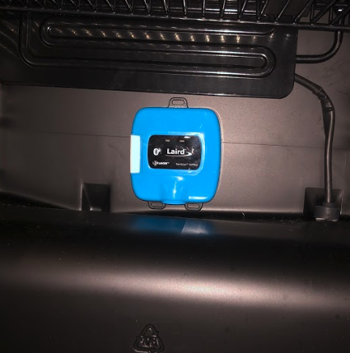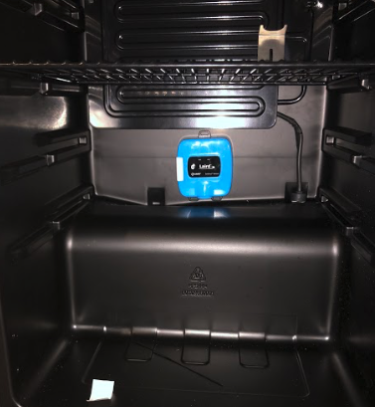

Mounted Temperature Sensors Inside Refrigerators

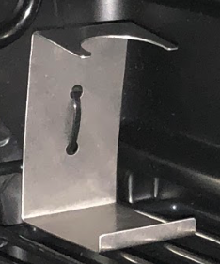

Mounting Bracket for Vial

Troubleshooting

Our platform maintains a history of device readings from the moment you activate your sensor. Each sensor is setup to report every 20 minutes. After installing, wait 60 minutes, and review the last three readings of the sensor to confirm it is ready.

- From your dashboard, select the sensor name
- On the History tab, review the average Signal Strength (dBm)

  - 2 digits (-99 or below) = Ok (-93.0 dBm)
    - Your sensor is online with strong signal

  - 3 digits (-100 or greater) = Not Ok (-101.0 dBm)
    - Your sensor is online with low signal

Adjust your Gateway closer to your sensors. If in a large space, an additional gateway is recommended.

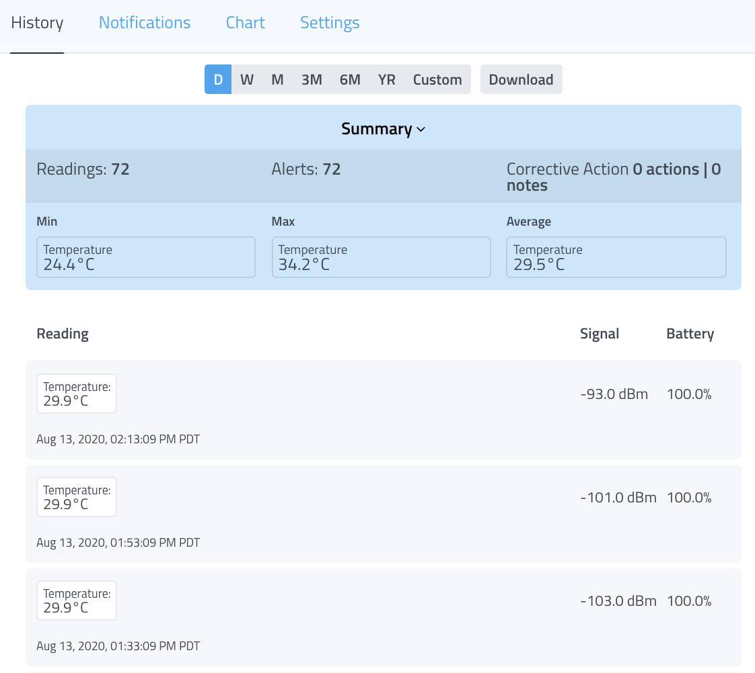
The 2 readings above -100 dBm suggest sensor requires closer Gateway

Sensor Maps

Easily view the status and position of your gateways & sensors on a Google Map or Image (such as a floorplan or photo of the location). Drag & drop icon markers to their correct position at the location and tap on them to pull up details on current status.

