Temperature Monitoring Solution

Training Guide

Training Guide
2020
IoT in a Box® 4
Temperature Monitoring Solution 4
What’s included? 5
Customizable Web and Mobile Apps 5
Gateways 5
Sensors 5
Getting Started 6
Locations/Departments 6
Guided Setup 7
Preconfigured Devices 7
Gateways 8
Installation Steps 8
Sensors 9
Installation Steps 9
Device History 10
Alerts 11
Alert Types 11
Alert Settings 11
Corrective Actions 11
User Management 12
How to Add Users 13
Reports 14
Regulatory Report 14
Regulatory Report Settings 15
Summary Report 16
Summary Report Settings 17
Corrective Action Report 17
Corrective Action Report Settings 19
Sensor Maps 20
Pin to Home screen 20
Customized Markers 20

IoT in a Box®

myDevices introduces IoT in a Box®, turnkey solutions that address remote monitoring challenges for a variety of verticals. Plug-and-play gateway and sensors are pre-configured with a LoRaWAN™ network connection and can be up and running in minutes.

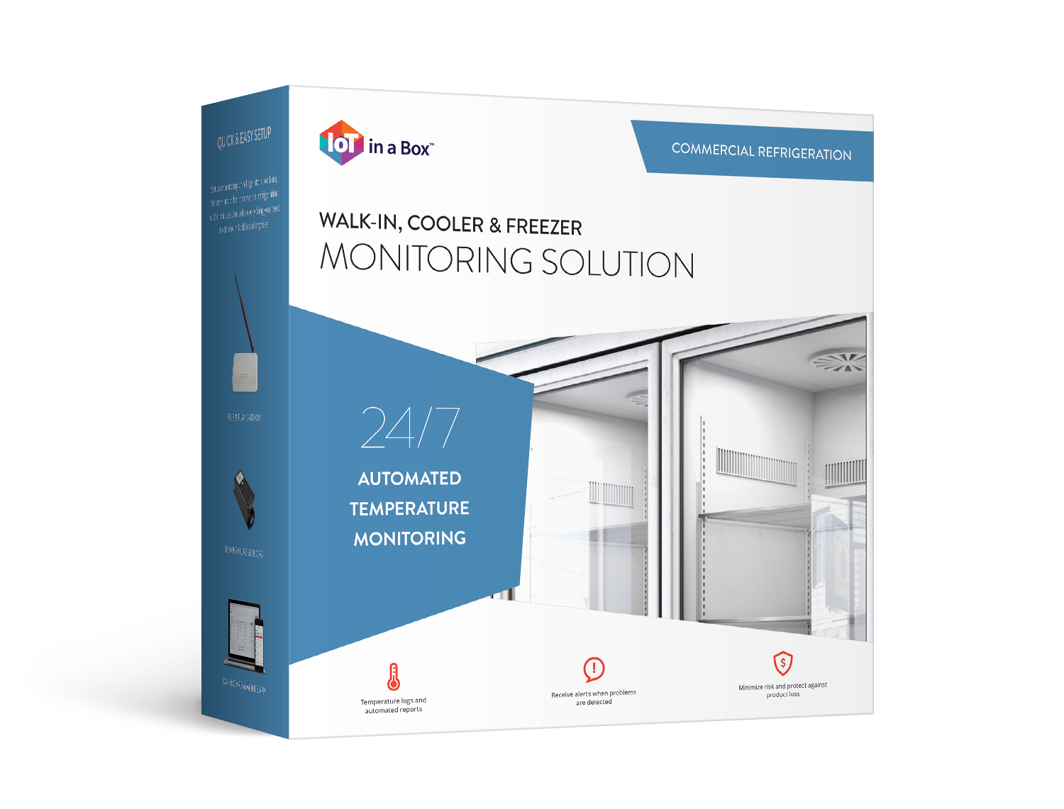
Temperature Monitoring Solution

Eliminate the time and effort of piecing together IoT solutions using our out-of-the-box ready Temperature Monitoring solutions. Our solution solves the unique and complex monitoring challenges by combining plug-and-play hardware with industry-leading monitoring applications, real-time reporting, and instant SMS text message alerts tailored for your vertical.

- Healthcare
- Food Service
- Retail
- Education
- Facility Management

What’s included?
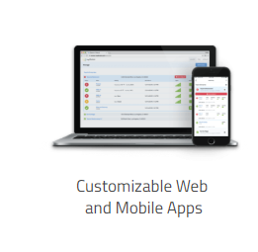

Customizable Web & Mobile Apps
Sensors
Gateways

myDevices IoT in a Box® provides you with tools to remotely monitor your business locations.

Customizable Web and Mobile Apps
- Monitor and control your companies, departments and locations by grouping gateways & sensors on a single dashboard using full-featured apps.
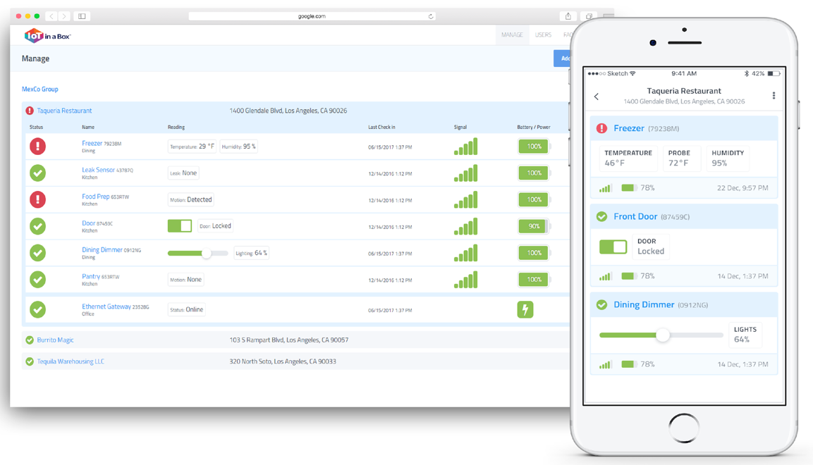

Gateways
- Preconfigured to work right out of the box – just add the gateway to your account by scanning the QR code on the back of the gateway.

Sensors
- Automatically connect with your gateway device – just scan the QR code on the back of the device and the sensor will automatically start sending data to the gateway periodically.

Getting Started
This training guide will provide you a complete overview on how to manage your temperature monitoring solution with the myDevices IoT in a Box® Solution.

Installed accounts would normally have an Account Administrator identified and created in the solution. New customers should setup their Account Administrator profile before adding devices.

- Create your account and add the main address of your facility. Next, add additional departments/locations.

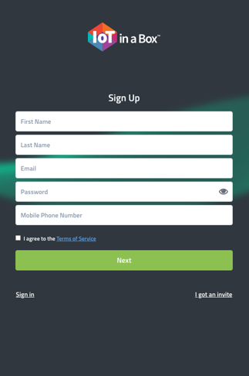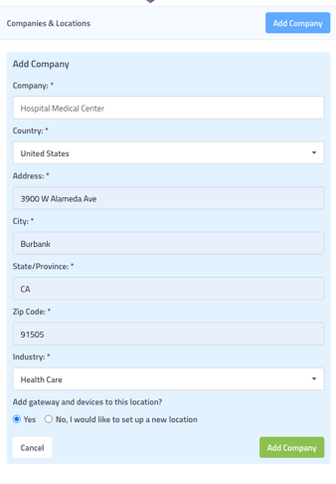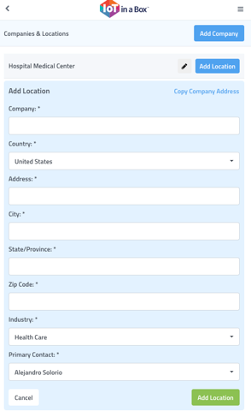

Locations/Departments

Remotely manage all of your sensors regardless of location from a single dashboard. Using our Web or Mobile apps you can contemporaneously get an overview of the status of any location or device. Stay at a high level to get an overview of the location or drill down to view current and historical device readings.

- Select Add Location to add and name additional areas to your account

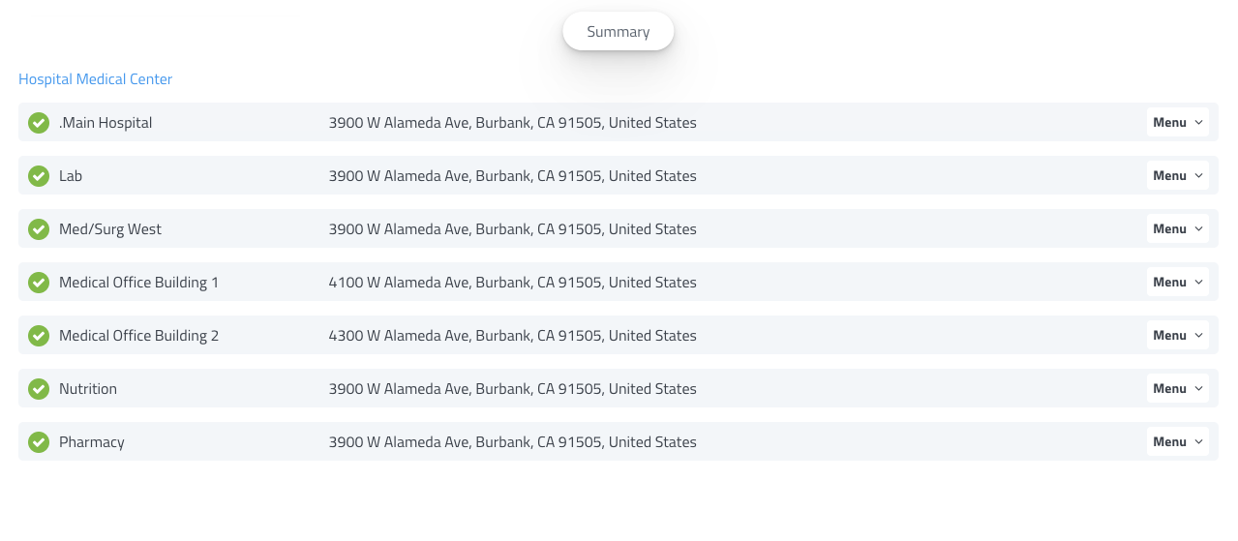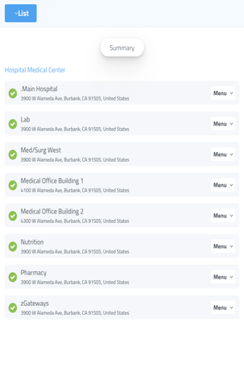
TIP: Users may be assigned to one or all locations, distribute your devices accordingly
TIP: For large accounts, you may add all your Gateways to a single location

Guided Setup

Get up and running quickly. After signing into your new account, use our guided setup to walk through setting up your Locations, Gateways and adding your devices.

TIP: If you plan to adjust sensor placement, please ensure the following tools are handy.

Preconfigured Devices

Our setup process makes adding new Gateway or Sensor devices pain free. Devices delivered to you preconfigured to work with your solution. To add your device, simply scan the QR code located on the back of the device.

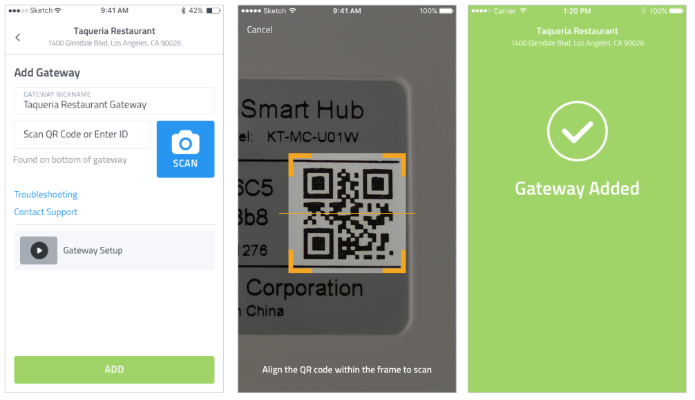

Gateways
Our devices are interchangeable, and each will work with any of your sensors.
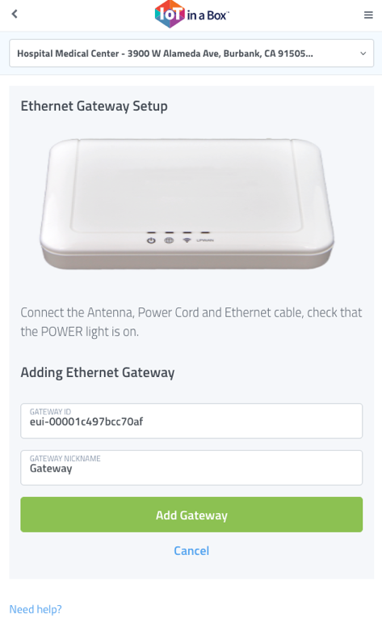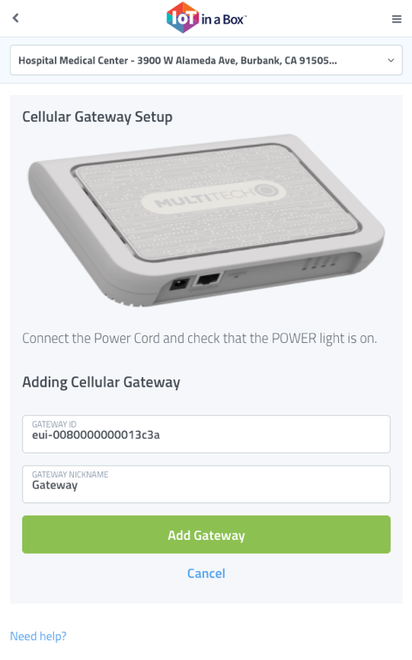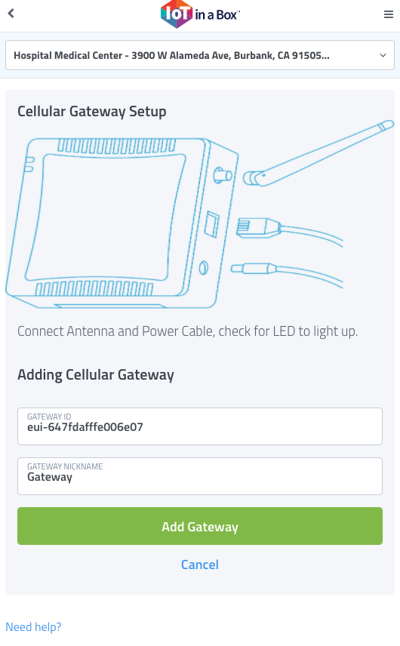

Installation Steps
- Scan in Gateway
- Power on Gateway and wait 3 min for each device to power on
- Secure Gateway with double-sided tape
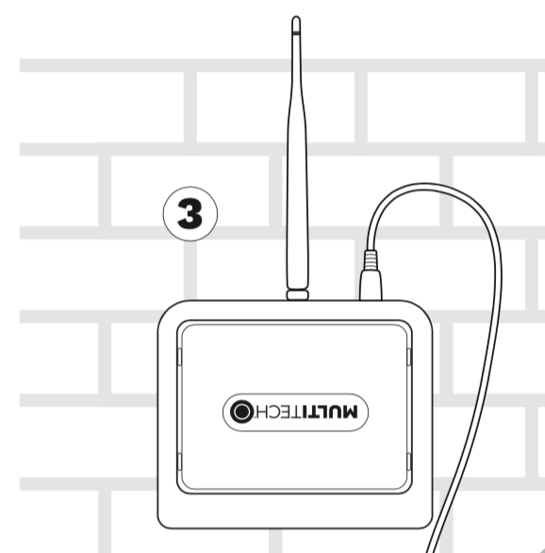

Sensors
Our devices are interchangeable, and each will work with any of your gateways.

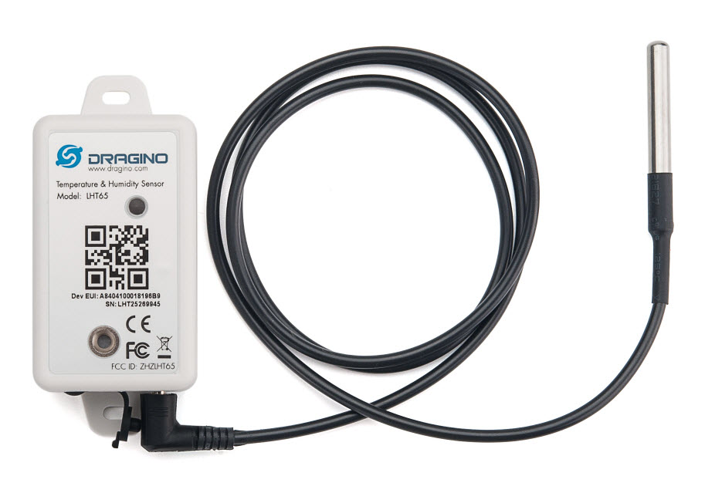

Installation Steps
- Scan sensor into app
- Activate the sensor next to the gateway & again inside monitoring unit
- Relocate the sensor if it does not connect online

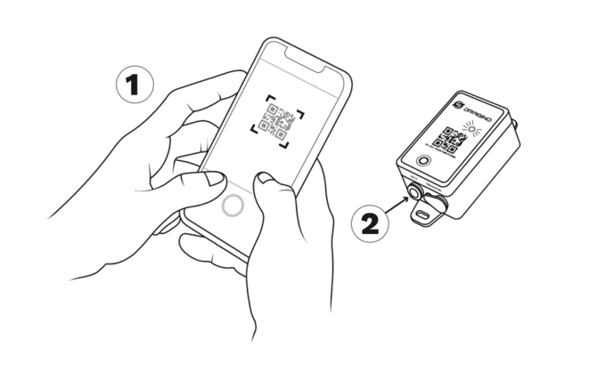

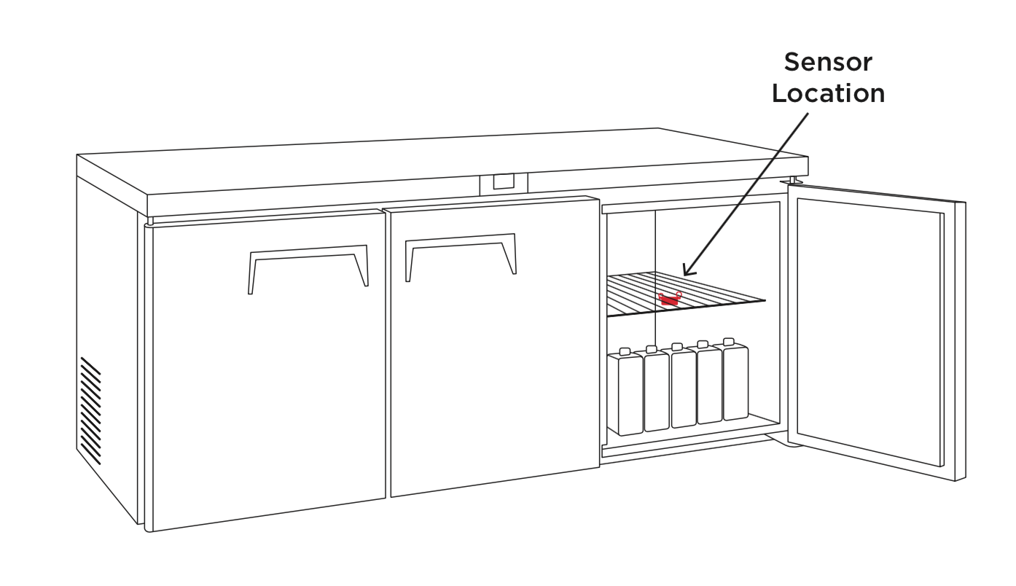

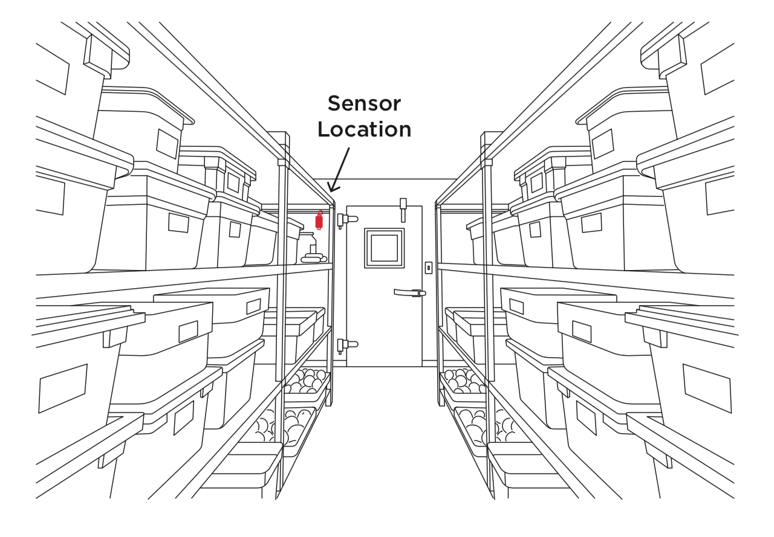
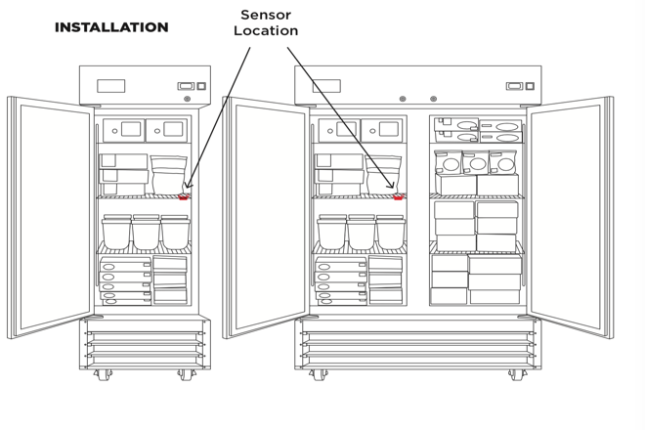

Device History

Our platform maintains a history of Device readings, Alert notifications, and Reports delivered. Using the Web or Mobile apps you can dig into the historical data, filter to show exactly what you need and download for your records or for offline viewing.

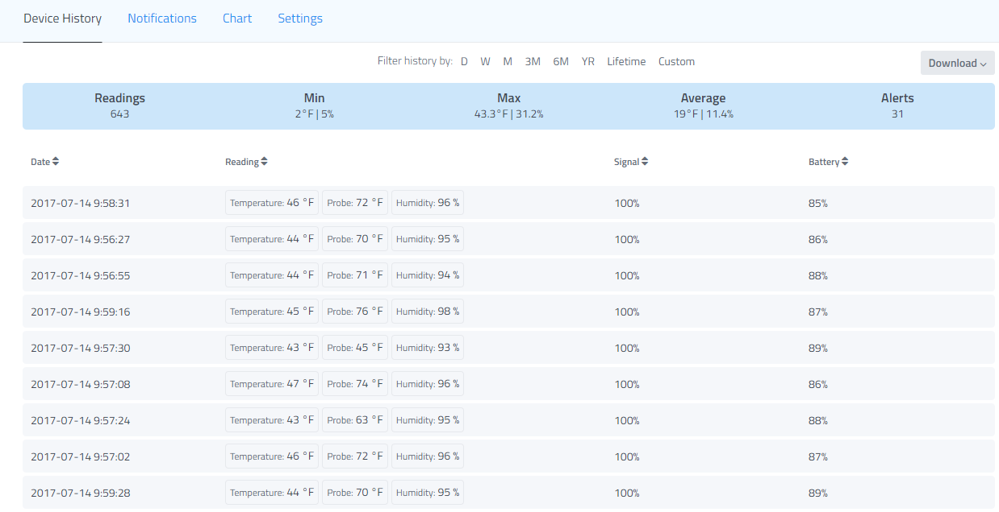

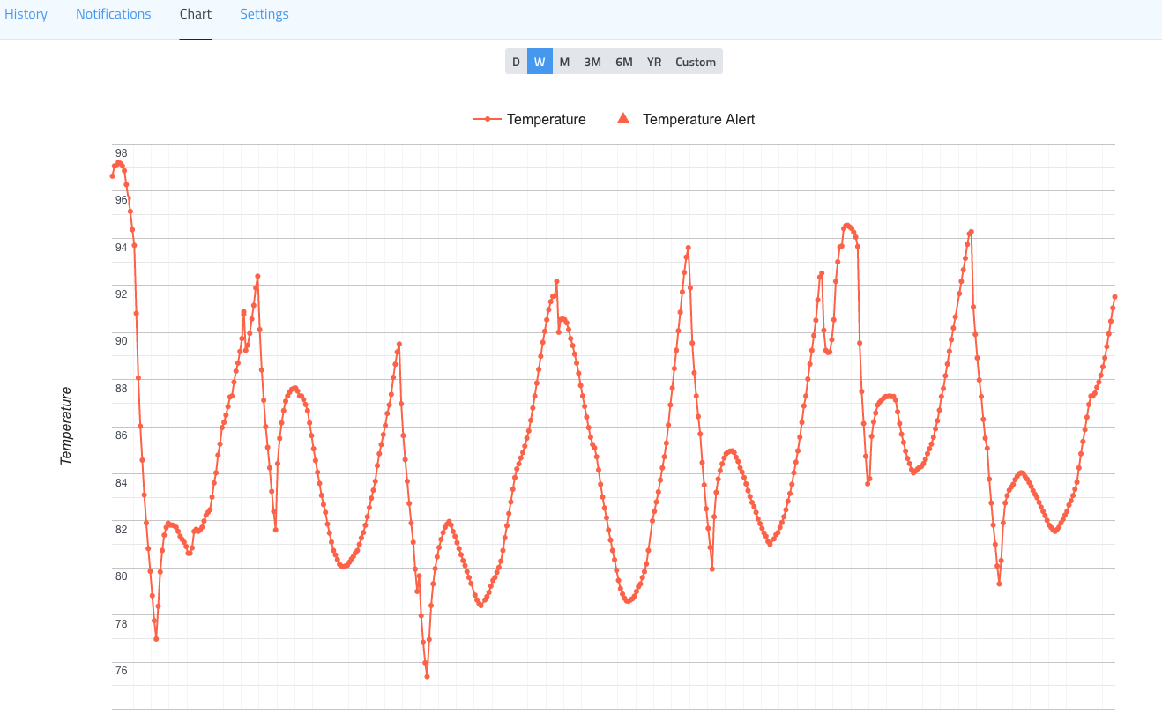

Alerts

Receive notifications when sensor readings deviate from normal. Our Alert system allows for customization of alerts – you control the conditions for alerting and who gets notified. Recipients can be notified by Text or Email message.

Alert Types

There are 4 alert types that can be managed in the solution.
- Gateway Online Alert – notifies users when a Gateway is offline and online
- Temperature Alert – notifies users when a temperature is out of range
- Humidity Alert – notifies users when humidity is out of range
- Probe Alert – notifies users when the probe’s temperature is out of range

Alert Settings

The following settings will be required to configure for each alert type.

- Gateways
  - Alert Recipients – users to receive alerts
- Temperature / Humidity / Probe
  - Thresholds – min and maximum range
  - Rule Condition – sets amount of time a device may out of range before alert is sent
  - Alert Recipients – users to receive alerts
  - Apply Settings to Other Devices – allows you to copy/duplicate the alert settings of one device to another (or all)

TIP: Edit one alert and use the Apply Settings to Other Devices feature to copy settings for all devices of similar settings.

Corrective Actions

Ease your regulatory and compliance burden by recording actions taken and adding notes for follow-up tasks for alert occurrences. Choose from a list of default Actions or add custom actions on the fly. Our system maintains a history of all alerts, notes and users involved for delivery and download in reports.

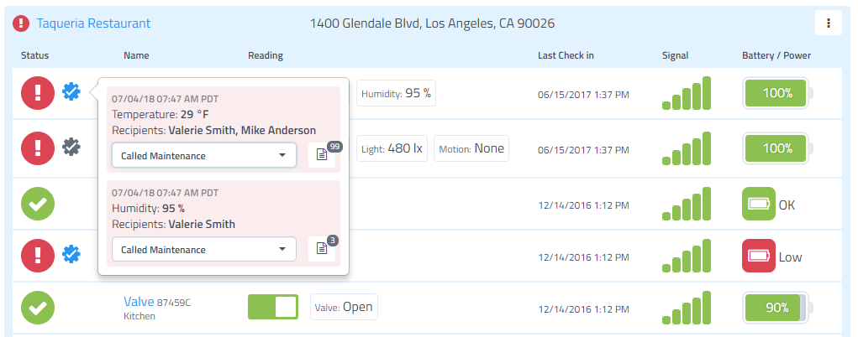

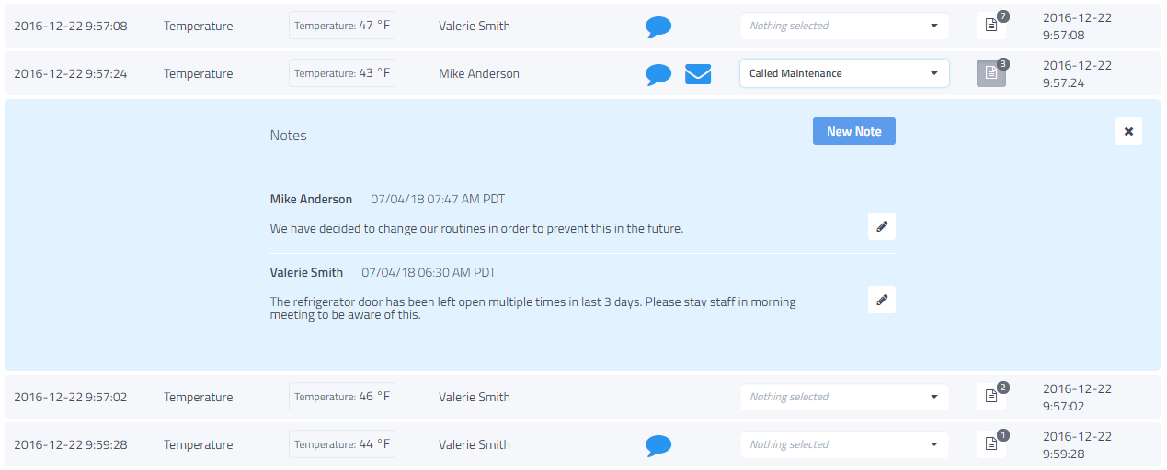

User Management

Easily review and control the various users, team members, personnel and contacts for at your various companies and locations. Quickly update contact information or Invite additional users to help manage locations through the Web or Mobile Apps. Define and control permissions to limit or grant access to account features, locations and facility access.

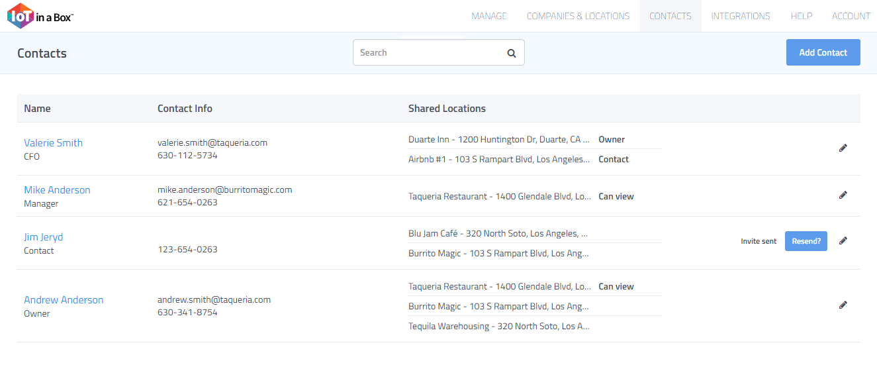

How to Add Users

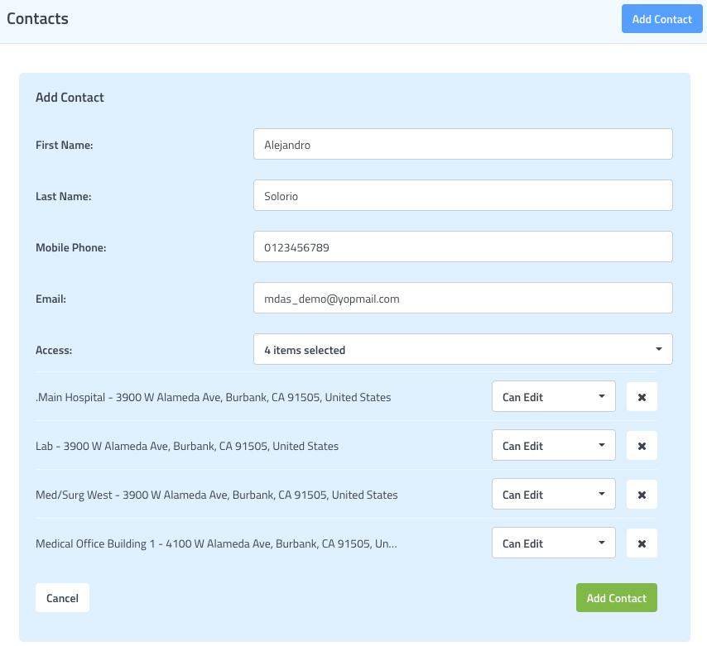

Reports

Our report types allow you to customize the data included by specifying any number of devices and readings, setting the time(s) for each reading, and choosing the number of days to include in the report. You select how much detail gets included in each of your reports.

The solution comes with 3 default reports that can be implemented into your everyday workflow.

- Regulatory Report – provides temperature readings for all devices at specified times.
- Corrective Action Report – provides all documentation entered by users in response to an alert.
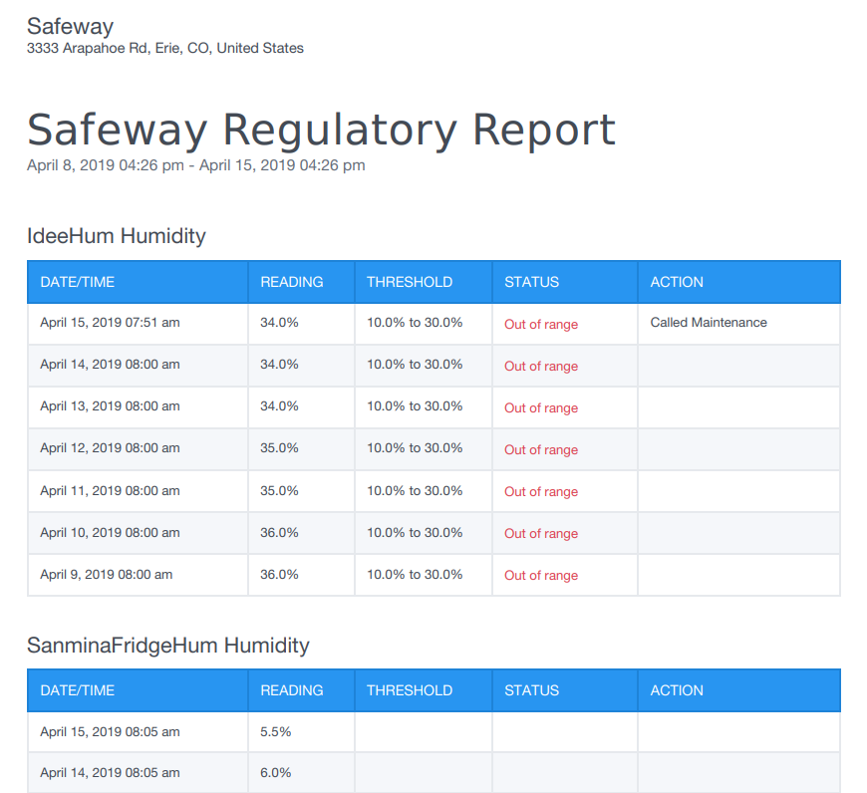
- Summary Report - provides a summary of readings and events for all devices.

Each report is emailed to users and can be configured to be sent Daily, Weekly, and Monthly.

Regulatory Report

Ease your regulatory compliance burden with detailed reports that show date/time of readings, recorded temperatures, temperature thresholds, range status, and corrective action(s) taken for out of range readings.

Regulatory Report Settings

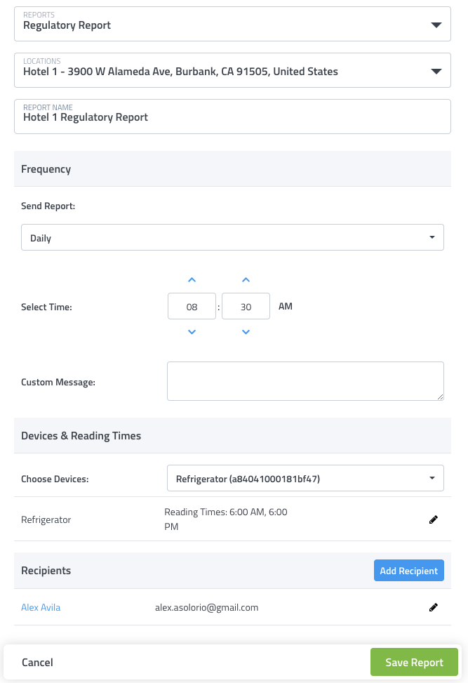

Summary Report

Receive automatic Daily, Weekly or Monthly reports for device activity at any location. These comprehensive reports give you device summary, reading charts and a history log of sensor readings – perfect for maintaining compliance logs. Create as many reports as needed, each with their own recipients and delivery options. A history of past reports is also available for download at any time.

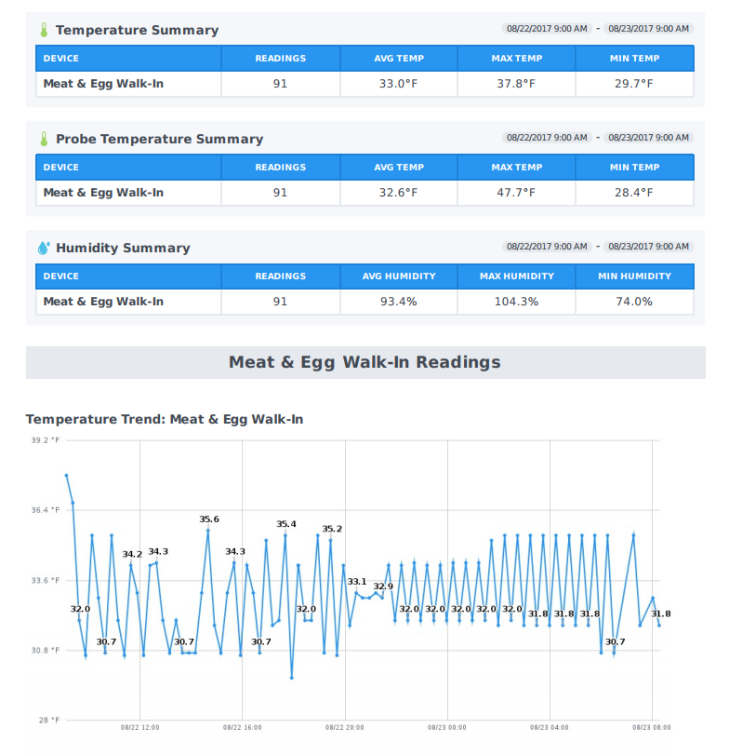

Summary Report Settings

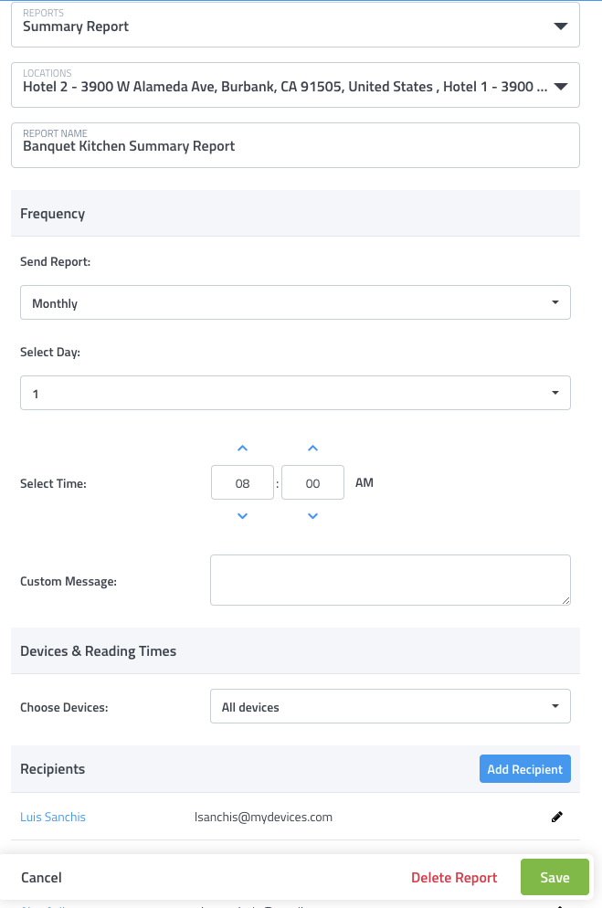

Corrective Action Report

Receive automatic Daily, Weekly or Monthly reports for devices for corrective actions taken. These action reports give you a summary of devices and alerts involved, actions taken in response and a list of any notes for follow up tasks recorded – perfect for compliance reports for regulations and inspectors. A history of past reports is also available for download at any time.

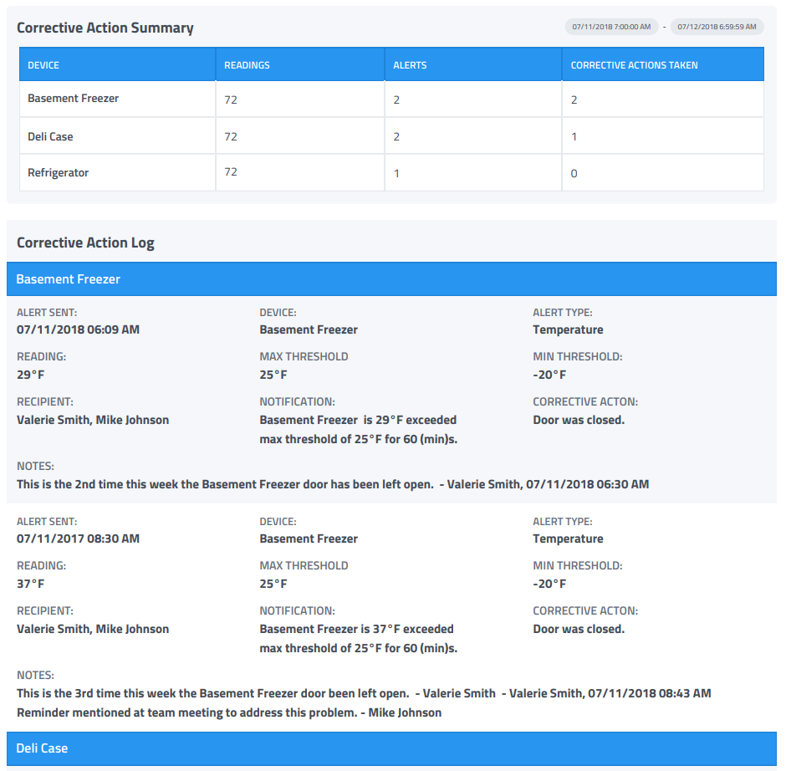

Corrective Action Report Settings
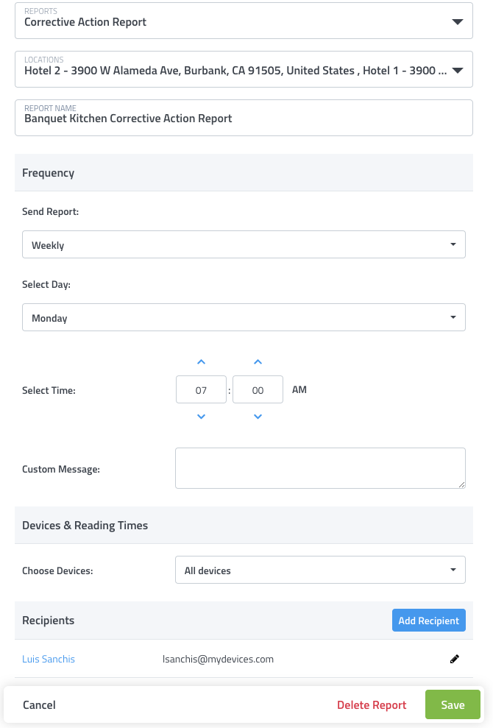

Sensor Maps

Easily view the status and position of your gateways & sensors on a Google Map or Image (such as a floorplan or photo of the location). Drag & drop icon markers to their correct position at the location and tap on them to pull up details on current status.

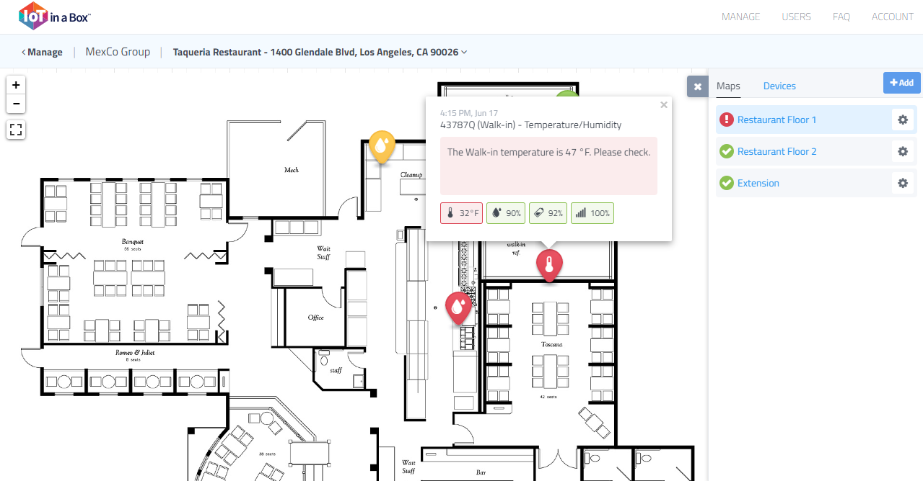

Pin to Home screen

Map pinning allows users to customize their home screen view by selecting any of their location’s map or floor plans to become the default view. Users can also pin their most important sensor map screens to the list, allowing quick selection directly from the home screen.

Customized Markers

Customize sensor map pin markers to adjust their appearance or replace the pin marker and show sensor data values directly on the map. Pin or sensor data values can also animate and play a sound to call attention to alert conditions on the map.

