Push+Protect Solution

Installation Guide

Installation Guide
2020
IoT in a Box® 4
Push+Protect Monitoring Solution 4
Pre-Installation 5
Deliverables 5
Asset List 5
Maps 5
Photos 6
Device Preparation 7
Account Preparation 8
Installation 9
Tools 9
Getting Started 9
Guest Rooms 10
Your First 2 Beacons 10
Testing & Troubleshooting Beacons 11
Common Rooms 13
Employee Lounges/Break Rooms 13
Stairwells 13
Housekeeping Storage Rooms 14
Post-Installation 14
Low Battery Beacons 14
Offline Beacons 15
Walkthrough 15
Transition Between Floors 16

IoT in a Box®

myDevices introduces IoT in a Box®, turnkey solutions that address remote monitoring challenges for a variety of verticals. Plug-and-play gateway and sensors are pre-configured with a LoRaWAN™ network connection and can be up and running in minutes.

Push+Protect Monitoring Solution

Eliminate the time and effort of piecing together IoT solutions using our out-of-the-box ready Push+Protect Monitoring solutions. Our solution solves the unique and complex monitoring challenges by combining plug-and-play hardware with industry-leading monitoring applications, real-time reporting, and instant SMS text message alerts tailored for your vertical.

- Hospitality
- Healthcare
- Food Service
- Retail
- Education
- Facility Management

Pre-Installation

To prepare for an installation we must have a complete understanding of the building the devices will be deployed, from guest rooms to common spaces to bungalows to off-site parking locations. Anywhere an emergency event may occur will need to be identified if coverage is to be extended to those areas.

Deliverables

The following deliverables are required to properly prepare for a Push+Protect Installation.

Asset List

Identify Rooms.
Provide a list of all rooms where an emergency event may occur, this includes all guest rooms and common rooms, including but not limited to: Stairwells, Breakrooms, Housekeeping Storage Rooms, and all other areas an emergency may occur.

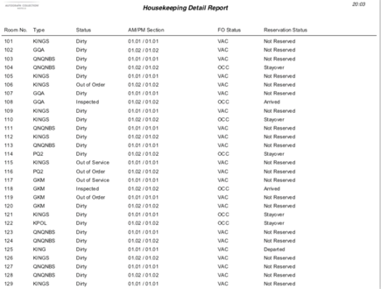
Sample Asset List Housekeeping Detail Report provides list of rooms.

Maps

Receive Maps of All Spaces.
Provide a labeled map that identifies each guest room by # and each common room by name. The less additional markings on a map, the better the user experience in the app.

TIP: When compared to the Asset List a labeled map will help ensure there are no gaps in coverage.

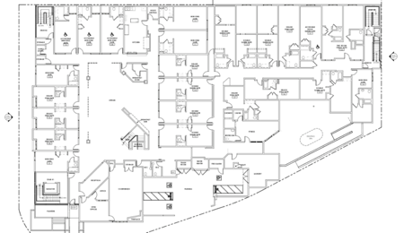
Sample Map Guest + Common Rooms are labeled on the map

Photos

Review Each Room Type Configuration.
Provide photos of each guest room type and common rooms to understand the orientation and determine best placement for beacons. Most of the pictures can be pulled from company websites, however, they may not fully showcase the room and most common room pictures are not available online. Renderings of room types or 360 videos are best.

Pictures: yellow dots showcase best recommended placement

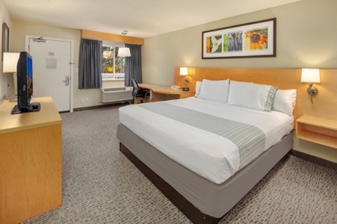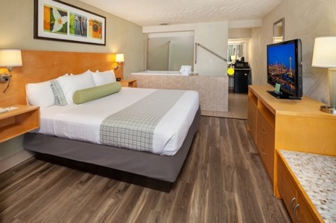
Sample Guest Room Type = King Room

Renderings: yellow dots showcase best recommended placement

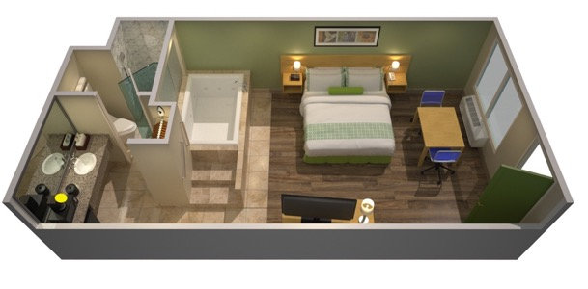
Sample Guest Room Type = King Room

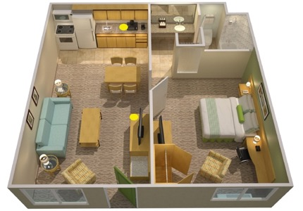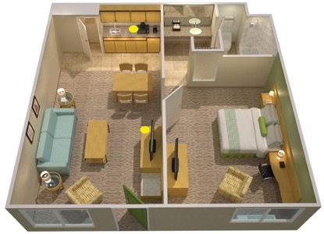
Sample Guest Room Type = King Room Apt Suite & Exec Suite

Device Preparation

Device Labeling.
Our team of experts prepare all devices with labels according to the asset list provided.

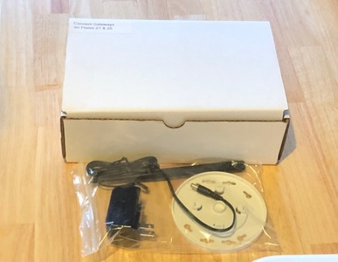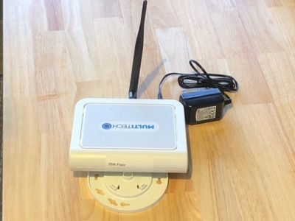
Gateways Box & Device label by floor

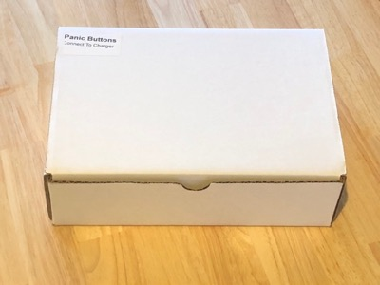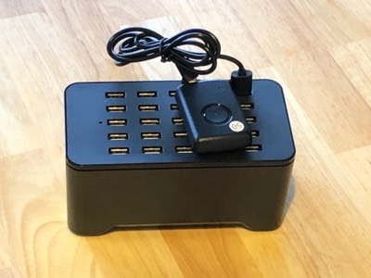
Panic Buttons Box & Devices labeled accordingly (Buttons labeled starting at #1)

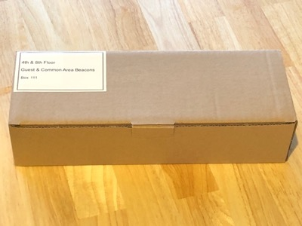
Beacons Box labeled by floor and room type

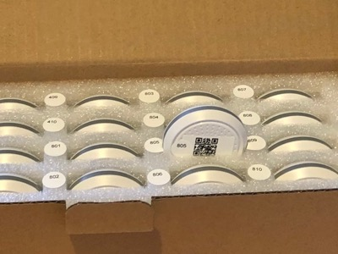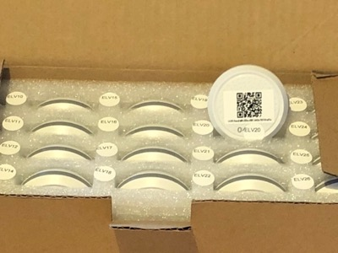
Beacons Guest Rooms labeled by Room # & Common Rooms w/abbreviated name (ELV = Elevator)

Account Preparation

Account Setup.
Our team of experts will not only create your account, they will also scan all your devices into the app for you! Most importantly, our team uploads your map and placed all devices on their designated space in your account. The Admin will have their login credentials created with a generic password that can be changed at any time.

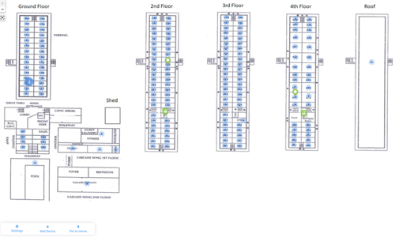
Sensor Map Our team will upload your map + devices

Installation

Tools

The following tools required for proper device setup and installation.

Install Tools In addition to tape, a drill may be used to secure Gateways

Getting Started

There are a few steps to take before the installation begins, like unboxing and gateway setup.

- Review inventory to confirm all equipment is present. Open all equipment and dispose of waste.

- Plug in charging station and panic buttons – you will need at least one throughout the install.
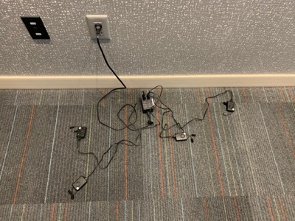

- To enable device communication, plug in your Gateways (commonly in IDF/Electrical closets).
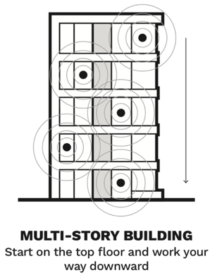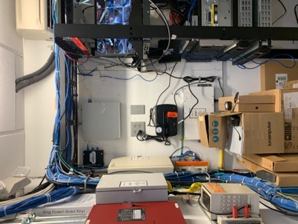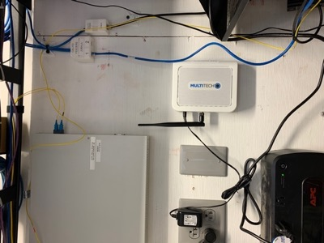

Guest Rooms

With your Gateways online and your Buttons charged, you are ready to install your beacons. For every room type you should test the placement of the beacon with adjacent rooms in order to ensure proper coverage and no bleed over. Start with adjacent vacant rooms.

Your First 2 Beacons

- One at a time, turn on your beacon before placing in its room. If the beacon does not power on, replace with a spare beacon.
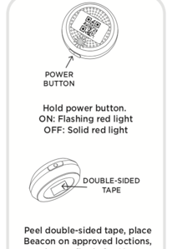
DO NOT Power on multiple beacons at one time

- For the first room type, review the submitted photos for recommended placement
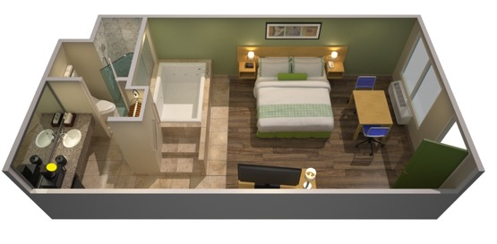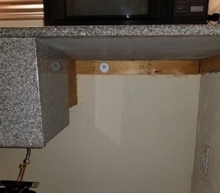
Recommended under sink (left) in sight of doorway. Beacon placed under sink (right).

- In adjacent room place beacon in its recommended location.
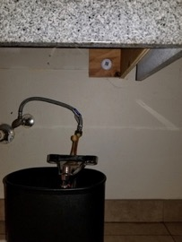
Adjacent room is same room type, so same placement

Testing & Troubleshooting Beacons

- Activate your panic button alert and test key areas: Doorway & Bathroom. Confirm the Location in the app is the same room you are in.

  - With 3 successful updates, the beacon placement can be duplicated for all similar types
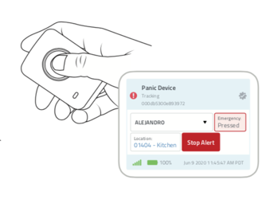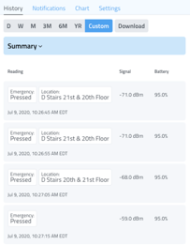
Press button twice to activate. Review app for updates. If alert is on, review text or email.

  - If the app is observed reporting adjacent room #, relocate the beacon

  - Relocate beacon towards center of the room, if in the back. Or to the back of the room, if in center
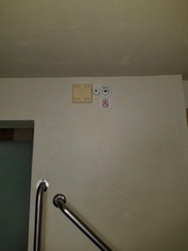
A simple adjustment can reduce any bleed over.

- Continue to the next set of rooms, and for every new room type you enter (Double bed, Suite, Corner room, etc.) repeat Steps 1 - 4.

Common Rooms

Common rooms work similar to guest rooms; however, they may present a larger open area. To provide optimal coverage ensure the beacon faces in the direction it will most view the room. Adjust placement as necessary to ensure all corners of the room report the correct location and any adjacent rooms do not bleed over.

Beacons should not be placed on back-to-back wall as it may cause bleed over into adjacent room.

Employee Lounges/Break Rooms

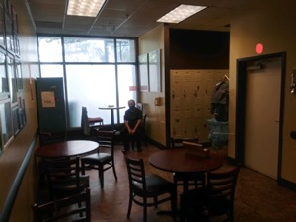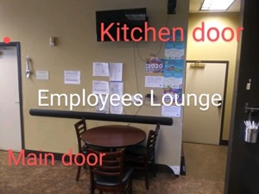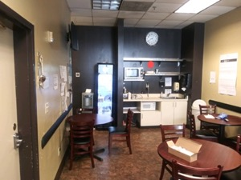
- Above the main door (left) does not provide full coverage by the Kitchen Door.
- Above the kitchen door (middle, right) does not provide full coverage by the lockers.
- Above the sink (right) provides a better view of the room & full room coverage.
Every Location Is Setup Different
(Submit photos to Support for Beacon Recommendation)

Stairwells

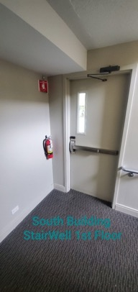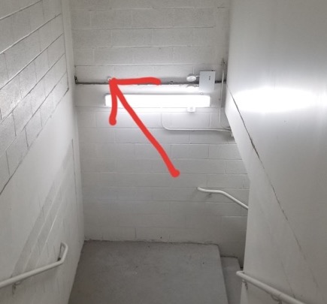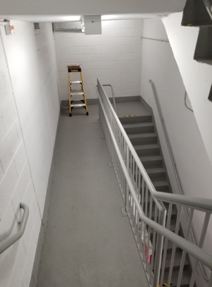
- If your door does not face stairs, install beacon facing stairs above fire sign (left)
- If your stair turns, install beacon facing doorway near (middle)
- If your stairs have a long walkway, install beacon facing doorway (right)
Every Location Is Setup Different
(Submit photos to Support for Beacon Recommendation)

Housekeeping Storage Rooms

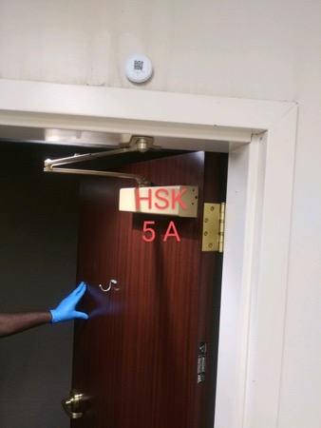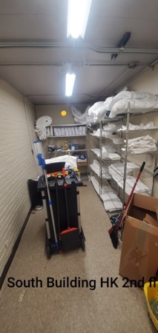
- Above the door or facing the door on the opposite end provides best room view
Every Location Is Setup Different
(Submit photos to Support for Beacon Recommendation)

Post-Installation

After installing all devices, conduct a final review and walkthrough to ensure all beacons are online, fully operational, and the app properly updates.

Low Battery Beacons

Review all beacons and ensure there are no beacons reporting less than 100%. For every beacon with battery reporting at less than 100%, replace with one of the spare beacons in the shipment.

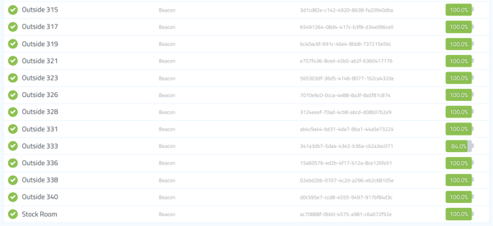
Shipments contain spare devices to replace any low battery beacons

Offline Beacons

Review the beacons dashboard for any beacons that did not activate online during installation. Offline beacons will not display a green check mark next to their name nor a battery icon next to their ID.

Beacon List Desktop – Offline Beacon (top) & Online Beacon (bottom)

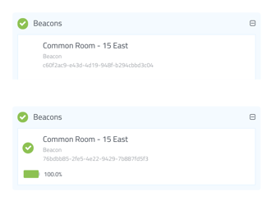
Beacon List Mobile – Offline Beacon (top) & Online Beacon (bottom)

TO ACTIVATE: stand nearby an offline beacon with a panic button in emergency mode.

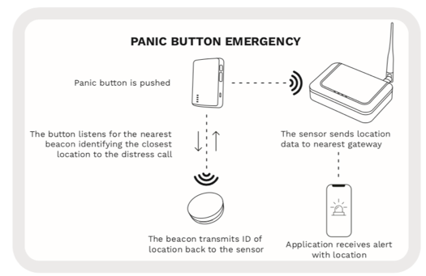
Panic Button registers Beacon ID to communicate back to the Gateway.

Walkthrough

After all devices are installed and online, with a panic button in emergency mode walk the floors and ensure every beacon communicates back to the system by tracking the button’s history.

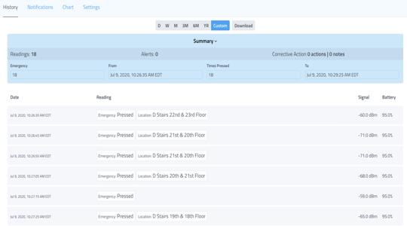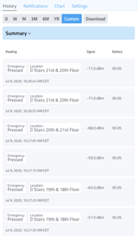
Reset or Replace any Beacon not Reporting during Walkthrough

Transition Between Floors

When conducting a walkthrough, during a transition between floors the system conducts a self-check to confirm the panic button is on a new floor, then it updates accordingly.

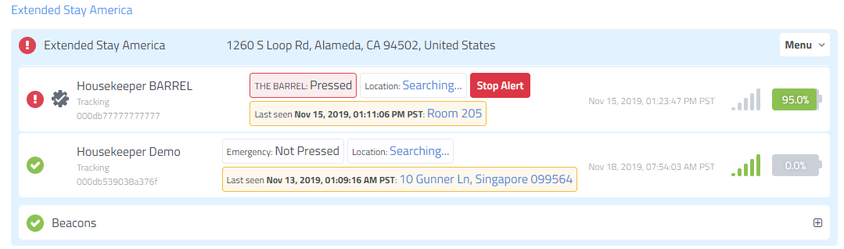
During transition on List View the button displays Searching...

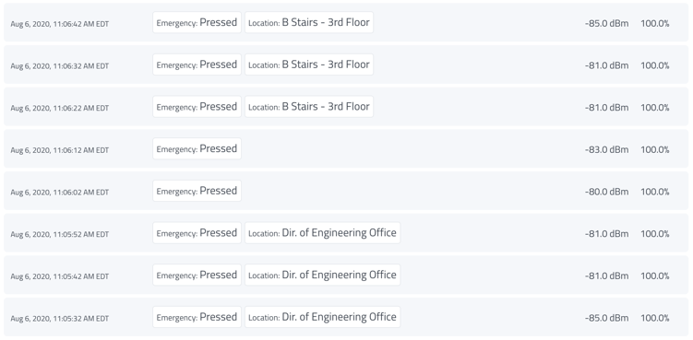
During transition on History View the button omits a Location.

